Lecture 10(i) Announcements

**Midterm Mon Nov 12, 7pm-8pm**

If conflict, register by Mon, (Nov 5), 4pm to avoid **late registration penalty**. Email head grader, headgrader@gmail.com

* Question and Answer Sessions
* Wed Nov 7: 4-5:30: Anderson 310
* Wed Nov 7, 7:30-9: Anderson 210
* Thur Nov 8 3:30-5 : Anderson 210

Don’t forget to vote for the carbon policy platforms at Canvas week 10 to get bonus points.

* No lecture on Friday or Monday of exam
* Office Hours this week (Hanson 4-135)
  + Wed: 1:30-3:30
  + Fri: 9:30-10:30
  + Don’t forget about TA off. hrs.
* Coverage: Lec 6(i)-Lec 10(ii)
  + Look at practice midterms
  + 3 Worksheets at Canvas.
  + Reading 4, Reading 5

Don’t Forget to Vote!

For 4 policies at Canvas

(get bonus points)

(Deadline same as HW 8)

* Lecture

1. Review finding profit on the graph.

2. More discussion of case of perfectly elastic long-run supply.

3. Entry and Exit

4. Apply this to looking at impact of China on consumer goods industries in the U.S. (Reading 6)

For future reference,

some points on ATC...

|  |  |
| --- | --- |
| q | ATC |
| 1 | 6 |
| 1.5 | 5.17 |
| 2 | 5 |
| 3 | 5.33 |
| 4 | 6 |

For midterm (and practice problem)

I will either give a table like this.

Or you find this information on the graph.

Cost Structure



qmin

firm q

Find profit when:

P = 7?

P = 3?

Cost Structure



qmin

firm q

|  |  |  |
| --- | --- | --- |
| Price  q min | Firm SR supply | Industry SR supply (N=100) |
| 3 | 1 | 1*100=100 |
| 4 | 1.5 | 1.5*100=150 |
| 5 | 2 | 2*100=200 |
| 7 | 3 | 3*100=300 |

Short-Run Supply (N=100)



D2

D1

D0

Start at D1.

What is long run equilibrium?

What is short-run supply curve?

Now shift to D0 or D2.

Short-run? Long-Run?

Review assumptions where

Long Run Industry Supply looks like this:

• Same Technology is available

for all

• No barriers to entry

• Input prices to industry do not go

up as the industry expands

Clear example: garden statue business



* Technology for making garden gnomes available for all.
* No restrictions to entry.
* It is such a small part of the market for all of its inputs (e.g. cement, paint, unskilled labor), that demand for garden gnomes could increase by a factor of 10 and it won’t make any difference for the price of the inputs.

We concluded: Long-run supply is perfectly elastic at P = MinATC

Another example?:

Taxicab business

(if not regulated by requiring a medallion for entry)

But in New York City

you need this



In 2013 medallion sold for $1.3 million. Now $160,000. Yikes!





Uber driver

Think of each car as a one firm.

Think of q is the number of hours the car is driven in a day.

Note: zero profit condition means zero profit net of opportunity costs

* Driver needs to get paid for opportunity cost of time
* Owner of vehicle gets return on investment

What about assumption of constant costs?

Recent evidence of very elastic supply of uber drivers

Paper by Hall, Horton, Knoepfle

<http://john-joseph-horton.com/papers/uber_price.pdf>



firm q

Suppose in long run equilibrium, but there is a temporary shift in demand?

Uber can use surpricing

What Happens with a Temporary Surge in Demand



Dsurge

Move along a short turn supply with

Dnormal

Q

NLR = 100 Uber drivers

If the surge turns out to be permanent, then what happens?

2. Other Cases of Long-Run Perfectly Elastic Supply?

Again the **Assumptions:**

• Same Technology is available

for all

• No barriers to entry

• Input prices to industry do not go

up as the industry expands

Other examples besides garden gnomes and Uber

How about week long ocean cruises?

* In short run # vessel fixed (and captains..) in short run as demand goes up price of cruise increases
* long-run get more entry (and captains....)

Should work for goods like:

* chicken...
* granite countertops

Should work for gasoline market for a small country like Norway

But why won’t the theory work as well for the gasoline market in the U.S. (Hint U.S. consumes a large share of world oil supply).

What about the market for playing 18 holes of golf in...

Manhattan?

Anywhere in North Dakota?

Impact of Imports (Reading 6)

Initial Situation: No imports from China.

(Because not developed enough or because of import restrictions)

New Situation:

Imports come in from China at price PChina

Distinguish between short and long run

Impact of Imports in the Short and Long Run

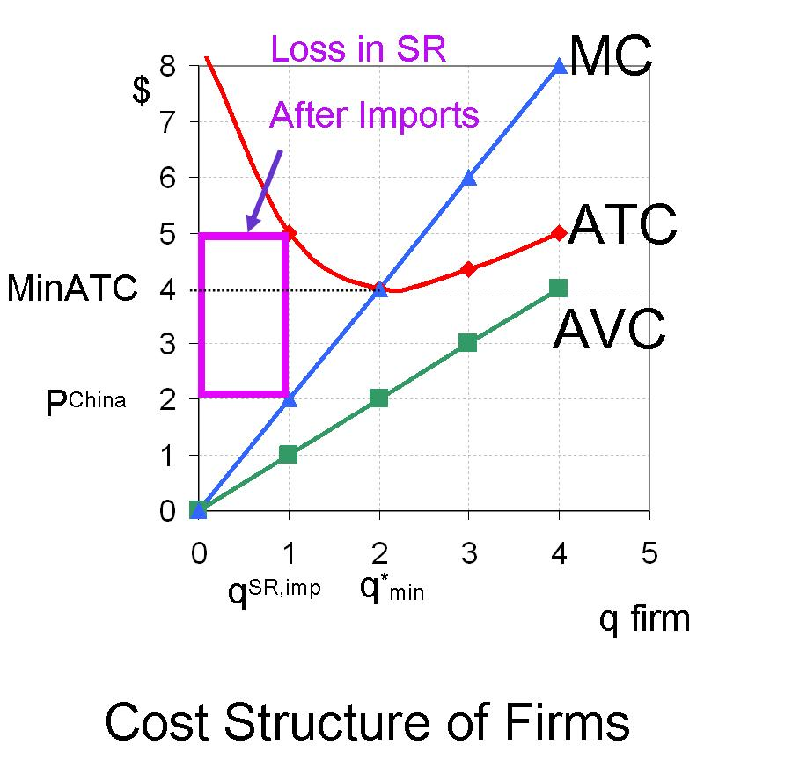

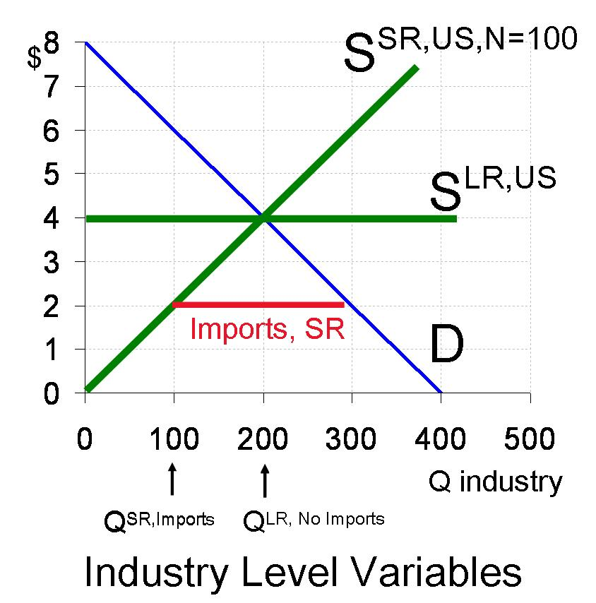

Initial Long Run Equilibrium

PLR=4, QLR=200, qLR=2,N=100

Short run impact:

QSR,US,Imports = ____________

PSR = _________

Imports, SR =_____

Long Run Impact

QLR,US,Imports = ____________

PLR = _________

Imports, LR = ________

Now look at a list of industries hit by a surge from China)

Reading 6

International Application

Consumer Goods Manufacturing:

The Rise of China and Plant Exit in the United States

All of these industries are intensive users of low-skill labor for assembly.

If have time let’s look for a few minutes at the clip “[With These Hands](http://www.youtube.com/watch?v=2_qKYolUU_A)”

<http://www.youtube.com/watch?v=2_qKYolUU_A>

About the last day of work at the Hooker furniture factory Virginia

(I’ve added a link at the bottom of Reading 6)

See lot of scenes of low skill workers doing routine tasks.

There are strong economic forces to move that kind of work outside of the U.S.

|  |  |  |  |  |
| --- | --- | --- | --- | --- |
|  | | | | |
| **Industry** | | | | |
| Curtain & drapery mills | | | | |
| Other household textile prod mill | | | | |
| Women's & girls' cut & sew dress | | | | |
| Women's & girls' cut & sew suit, | | | | |
| Infants' cut & sew apparel mfg | | | | |
| Hat, cap, & millinery mfg | | | | |
| Glove & mitten mfg | | | | |
| Men's & boys' neckwear mfg | | | | |
| Other apparel accessories | | | | |
| Blankbook, looseleaf binder, | | | | |
| Power-driven handtool mfg | | | | |
| Electronic computer mfg | | | | |
| Electric housewares & fan mfg | | | | |
| Wood household furniture mfg | | | | |
| Metal household furniture mfg | | | | |
| Silverware & plated ware mfg | | | | |
| Costume jewelry & novelty mfg | | | | |
| Mean of China Surge Industries (N=17) | | | | |
| Import Share Shipments  (percent) | | China Share Imports  (percent) | | Percent Change in U.S Employment  1997-2007 |
| 1997 | 2007 | 1997 | 2007 |
| 8 | 56 | 38 | 65 | -47 |
| 22 | 68 | 25 | 49 | -51 |
| 29 | 67 | 21 | 55 | -71 |
| 48 | 92 | 19 | 49 | -91 |
| 60 | 99 | 08 | 62 | -97 |
| 44 | 80 | 26 | 67 | -74 |
| 58 | 88 | 50 | 63 | -78 |
| 25 | 56 | 02 | 59 | -67 |
| 39 | 80 | 35 | 64 | -75 |
| 18 | 47 | 43 | 52 | -51 |
| 28 | 56 | 18 | 46 | -56 |
| 12 | 49 | 0 | 56 | -68 |
| 52 | 78 | 48 | 76 | -54 |
| 29 | 62 | 18 | 46 | -51 |
| 29 | 55 | 37 | 85 | -48 |
| 44 | 91 | 31 | 73 | -82 |
| 31 | 68 | 31 | 67 | -63 |
| 34 | 70 | 26 | 61 | -66 |

Within industries, the segments that have survived tend to be different from the part that has left.

Example of wood furniture industry

* In 1997 and earlier, dominated by places like Highpoint, NC
* Large plants making standardized products for mass market.
* These places mostly in South
* Custom, hand crafted segment scattered around the country in small plants
  + Need to be close to supply of craftsman (e.g. Amish)
  + Good to be close to consumers for custom work

Example of clothing industry

* Also dominated by places in the South
* New York city retained fashion element in small craft-oriented plants

What has happened?

* China is knocking out the large plants in North Carolina making standardized goods for the mass market.(China the new North Carolina)
* Small plants doing custom work have increased share (and places like New York)

China’s comparative advantage is weakest in:

1) Custom element (helps to be close for this, quicker turnaround, better communication.

2) Cases where high end niche products, with premium on fashion and creativity.

Even for these segments, prospects not great not always so great for American manufacturers

1) segment small

2) communication getting better so possible to do custom at a distance.

3) China moving up quality ladder.