Lecture 12(i)

Announcements

* Final Exam
  + Cumulative (so midterm1 and midterm 2 very important)
  + Also new material (and 2 worksheets)
* 3 more homeworks+1 debate

Lecture

Global Issue: Intellectual Property Protection and the Global Economy

This Lecture:

Focus on Pharmaceutical Drug Pricing and Intellectual Property (Reading 6)

Key Features of the Drug Industry:

* Expensive to generate new drugs (about industry claims to invest about $40 billion a year, estimates are around 800 million a new drug.)
* Patent: an incentive to make the investments. Get a monopoly for 17 years from grant date or 20 from application date.
* Look what happens when the patent runs out...

Zocor (Patent expired June 2006)

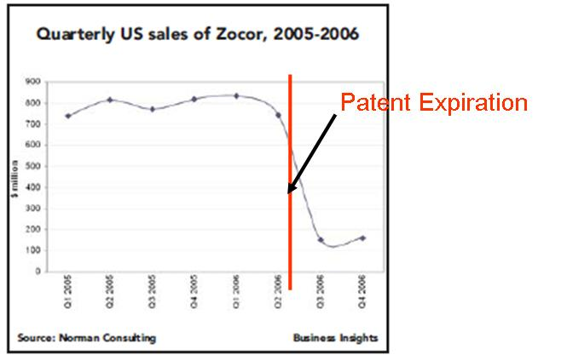

Lipitor (best selling drug of all time, 10 billion a year to Pfizer) expired last fall, has lost huge fraction of sales. Fact: U.S. is disproportionate source of drug company revenues.

* Zocor as example for 2005
  + $4.4 billion worldwide
  + $3.1 billion in U.S.
* Other estimates U.S. is around half of market
  + But only 5% of people and 25% of income
* Examples of Canada and Germany

Example of a Global Drug Market

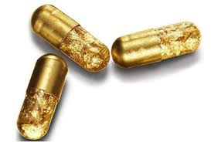

Wigitor

Cures Economyosis

Econland Big Pharma, Inc is deciding whether to invest in developing Wigitor.

First step: what is operating profit given invest in the drug?

Below is the demand curve of a 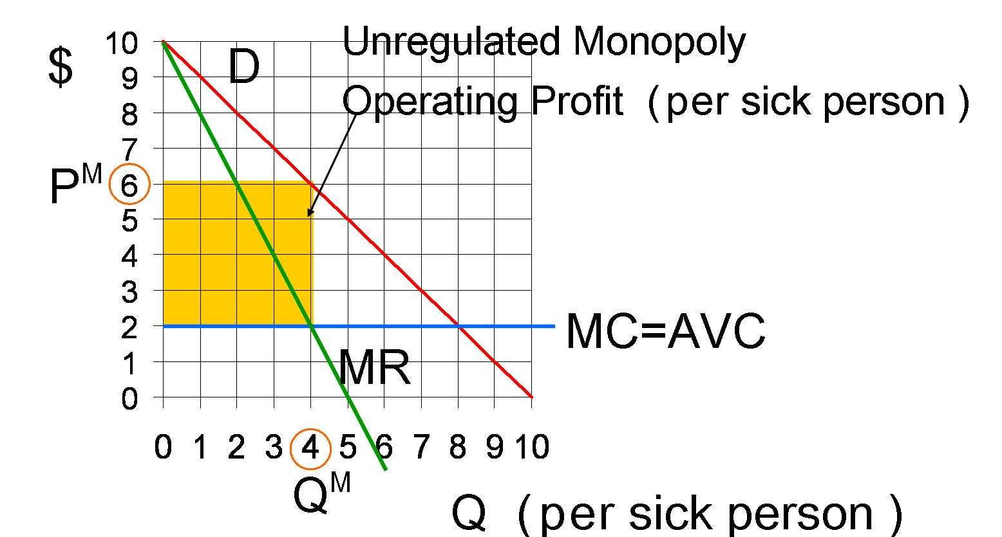person sick with Economyosis

Case A: Patent and unregulated Monopoly

In the news: taking advantage of unregulated drug pricing in the U.S.

Martin Shkreli (raised price of pill from $13.50 to $750)

Valeant, buying old drugs and raising prices.

Case B: No Patent

* Like US after patent expires
* Equivalently, this is what happens of there is a patent but it is not enforced (like often happens in developing countries like India.)

Assume entry costs are zero.

Free entry drives price down to

MC = $2.

Operating profit = 0

* 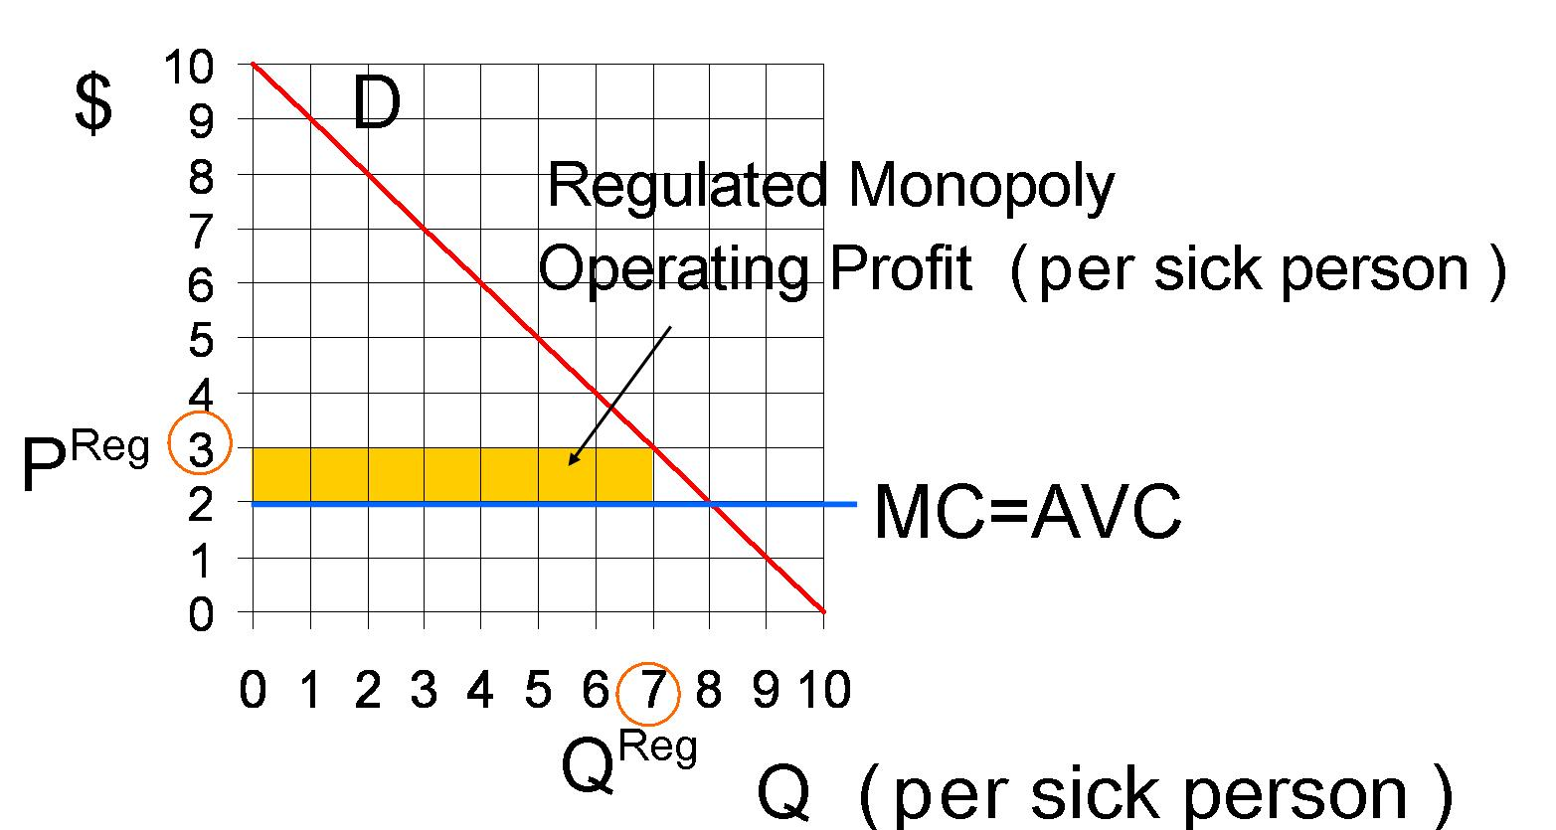

Case C: Patent but Pricing Regulation (Suppose can’t charge more than $3).

Next step: Is it profit-maximizing to invest? Need more information....

|  |  |  |  |
| --- | --- | --- | --- |
|  | US | Other Developed | Rest |
| System | Patent,  Unreg Monopoly | Patent,  Reg  Monopoly | No  Patents |
| Oper.  Profit per sick person  (annual) | $16 | $7 | 0 |
| Pop. | 300 mil | 600 mil | doesn’t matter |
| Share sick | 10% | 10% | doesn’t matter |
| Number sick | 30 mil | 60 mil | doesn’t matter |
| Annual Op Prof. | $480 mil | $420 mil | 0 |

Global Annual Op. Profit = $900 mil

Take into account 17 year patent life of drug (and not taking into account interest rates)

Lifetime operating profit:

17×$900 million a year

= $15 billion

(If take into account interest rates can cut quite a bit out of this.)

Look at incentive for innovation.

Take into account:

1) Cost of Research and Development (fixed cost)

2) Likelihood of success. Suppose 50/50 chance.

Expected Lifetime operating Profit

= .5×15 billion + .5×0

= $7.5 billion

Net expected value of investment

=Expected Lifetime Op. Profit

− Fixed Cost of R&D

= $7.5 billion − Fixed Cost of R&D

If Fixed cost>7.5 billion, definitely don’t do it.

Lose money in expected value (bad)

Suffer risk (that’s bad too).

If Fixed Cost < 9 billion, might want to do it.

Depends upon

(1) How much risk the company can tolerate?

(2) How low is the fixed cost?

Suppose fixed cost is 800 million (a typical R&D cost for big time drugs). Pretty sure drug companies would like these odds.

Now discuss changes in policy.

Policy Proposal 1

The U.S. adopts price regulation like Canada.

Operating profit per year is $7 instead of $16 per sick person. Annual operating profit in US is then

30million×$7 = $210

(instead of $480)

Global annual op. profit is

$210+$420 = $630 million a year.

About 2/3 of what it was before.

Less incentive to create the drug.

If fixed cost not too high, still might do it. But if big enough, won’t do it now. (but otherwise would.)

When people argue that that the U.S. should not regulate drug prices, often this is the argument they are making.

One counter to this argument might be: Why does the US have to pay a disproportionate share of all of this? (Even relative to other rich countries).

One possible answer: If the U.S. cuts back it will make a big difference in the incentives for R&D.

If Canada moved to our system, would that increase the incentive for drug companies to do innovation?

Not much, because Canada is a small percent of the global market.

(Unless there are diseases specific to Canada...)

Issues are similar if keep unregulated monopoly, but change patent system.

For example, suppose 5 year patent instead of 17 years. Then

expected lifetime operating profit equals $2.25 billion.

Tradeoffs (for total surplus)

(1) Plus Side:

Might still do it anyway. In which case have monopoly for 5 years instead of 17 years. Less deadweight loss of monopoly. (And less transfer of surplus to drug companies)

(2) Minus Side

Drug might not be developed.

Lose health benefits of wigitor.

(Comment: might not be such a loss if this is a “me too” drug that has close substitutes).

One more thing, suppose drug treats tuberculosis (TB) instead.

The table on the right provides the numbers.

It is clear that Econland Big Pharma not doing this. Makes no money because the people who get sick with TB don’t have any money.

Numbers for TB Drug

|  |  |  |  |
| --- | --- | --- | --- |
|  | US | Other Developed | Rest |
| System | Patent,  Unreg Monopoly | Patent,  Reg  Monopoly | No  Patents |
| Oper.  Profit | $16 | $7 | 0 |
| Pop. | 300 mil | 700 mil | 6 bill |
| Share sick | 0% | 0% | .2% |
| Number sick | 0 mil | 0 mil | 12 mill |
| Annual Op Prof. | 0 mil | 0 mil | 0 |

Global Annual Op. Profit = 0 mil

As the free market will not provide powerful incentives for TB innovation, how can it get financed?

1) There are government subsidies (for example, through the United Nations)

2) Private Charity

The Bill and Melinda Gates Foundation has paid $750 million for TB research

Summary of Policy Proposal 1

The U.S. adopts price regulation like Canada.

**Point 1: With this proposal there is less incentive to invest to create the drug.**

**Point 2: If the fixed cost is not too high, the company might still invest. In this case, we still get the drug and pay only $3 per dose instead of the monopoly price of $6.**

Policy Proposal 2

The patent length is changed from 17 years to 5 years.

The payout in operating profit is substantially reduced. Again

Point 1: Drug might not be developed

(minus side for this policy)

Point 2: If the fixed cost is not too high, the drug company might do it anyway. In this case, have monopoly for 5 years instead of 17. So less deadweight loss of monopoly (and less transfer of surplus to drug companies.)

Policy Proposal 3

Negotiate with the developing world (e.g. India and China) to adopt developed world (e.g. U.S., Europe, Japan) intellectual property standards.

**International Agreements**

Trade-Related Aspects of Intellectual Property Rights TRIPS, signed 1995, into effect 2005

India and other developing countries agreed to respect drug patents in return trade concessions made by rich countries on other issues. (Like rich countries opening up markets to textile imports from poor countries.)Before this, India did not recognized drug patents.

Trans-Pacific Partnership

Includes provisions extending patents.

Trump pulled the U.S. out, but other Pacific countries appear to be going ahead with it.

Policy Proposal 4

Finance pharmaceutical research through government research grants and put the results in the public domain to be freely used.

We do this to some extent, maybe we should do more?

* Public radio
* Health R&D through National Institute of Health
* Music (grants, Mozart sponsored by various princes

Raises issue of international cooperation. How do we split the bill with other countries?