Lecture 13(i) Announcements

Average of HW 1-9 posted at Canvas

Two more to go:

* HW 10 due Tues, Dec 4
* HW 11 due Tues, Dec 11

Drop the two lowest homeworks.

If you skip HW 10 and HW 11, the current average is we will use for your final score.

**Better idea**: Do well on HW 10 and HW 11, so two earlier low scores can get dropped.

Final Exam OneStop Page at the very bottom of Canvas: One stop shopping for all your final preparation needs, including questions from previous finals.

Lecture on Game Theory

1. Prisoners’ Dilemma

2. The Simple Version of the Battle of the Sexes

3. The Battle of the Sexes with Some Strategic Moves

4. Rock Paper ‘Scissors

5. Chicken

Game Theory

We have worked through Monopoly and Perfect Competition. What happens in between?

Oligopoly

With a few sellers, how do they interact?

Take OPEC (the cartel of oil producing nations).

Gains for the group to for each to hold back oil production to keep up the price. So each county in cartel gets a production quota.

Gain for the individual decision marker to deviate from the agreement and secretly sell more than the quota amount at the high price.

How does it all work out?

Game Theory is a useful tool

Prisoner’s Dilemma

Scenario: Robinson and Friday have been caught trying to steal widgets from S4. Have been brought in for questioning. They are being kept in separate rooms.

Each chooses between two actions:

Confess or Remain Silent.

The outcome depends upon what they both do.

Let’s look at the Payoff Matrix

Payoff Matrix (minus)

How Years in Jail Depend Upon Both Actions

**Robinson**

**Stay Silent**

**Confess**

**Stay Silent**

**F gets 8**

**Friday**

**Confess**

**R gets 8**

**R gets 20**

**R gets 1**

**R gets 0**

**F gets 20**

**F gets 1**

**F gets 0**

Strategy: a rule for how a player in the game behaves.

Look at incentives for Friday.

Suppose he thinks Robinson is staying silent....

Suppose he thinks Robinson is going to confess....

Nash Equilibrium

Player 1’s strategy is optimal for him or her taking as given how Player 2 is behaves.

Likewise for Player 2’s strategy.

Nash Equilibrium of this game:

This equilibrium is particularly compelling because it is special. Each choice made is a

Dominant Strategy

Optimal regardless of what they other person does

Let’s look at the efficiency of the equilibrium outcome from the perspective of the two players of the game.

Equilibrium Outcome:

Both confess and each gets 8 years in jail.

If instead neither confess, each gets only 1 year in jail.

If they could cooperate, (somehow commit to not confessing), both parties would be better off.

The Battle of the Sexes





**Female**



**Watch Ariana Grande**

**Watch**

**Football**

**Watch Ariana**

**Grande**

**M gets 3**

**Male**

**Watch Football**

**F gets 1**

**F gets 0**

**F gets 3**

**F gets 0**

**M gets 0**

**M gets 1**

**M gets 0**

Suppose the two players simultaneously make their choice. Let’s figure out the optimal strategy for each player

Look at incentives for the male player:

Suppose he thinks female is going to watch football....

Suppose he thinks the female is going to watch Ariana.

Look at incentives for the female player:

Suppose she thinks male is going to watch football....

Suppose she thinks the male is going to watch Ariana...

What are the Nash Equilibria of this simultaneous-move game?

Let’s change the game so that the action is sequential.

Female moves first. Sends text message to male about her decision. Then male moves. What is the equilibrium outcome now if the male rationally optimizes given the female’s choice?

**First Mover Advantage**

Lets change it one more time. Like above, female picks show before male, and sends text message to male, after picking her show..

But before the female picks her show, the male makes a deal with all his friends that if any of them hears that he watched Ariana, they all will defriend him on Facebook Snapchat Suppose the male really likes having Snapchat friends, and if he is defriended by all the guys he suffers a **loss of** **10**.

After this move, the payoffs look like:

The Battle of the Sexes

If male is defriended from

when he watches Ariana.





**Female**



**Watch Ariana**

**Watch**

**Football**

**Watch Ariana**

**M gets 3**

**Male**

**Watch Football**

**F gets 1**

**F gets 0**

**F gets 3**

**F gets 0**

**M gets 0 −10**

**= −10**

**M gets 1 − 10**

**= − 9**

**M gets 0**

Now work out the equilibrium when each player is forward-looking and assumes the other player will play rationally, given the choices already made by the other player. To solve this, need to work backwards and look at the endgame.

Suppose the male strikes the deal with his friends to defriend him if he watches Ariana.

Then regardless the female’s choice, in the endgame, the male will choose __________

Anticipating the male’s behavior, the female will choose _________

Anticipating how the female will respond to pact with friends, the male will make the pact.

This move on the male’s part is something like the famous example of Cortez burning his ships after landing in Mexico in 1519. He was playing a game with his soldiers. Fighting the Aztec Indians then became a better option for the soldiers than retreating back to the ships.

This is a taste of game theory.

More than being fun and interesting, it is a powerful tool for social scientists to study important strategic interactions.

(Mention this because this is a Social Science Core Class)

Test your knowledge: What is Nash equilibrium when Robinson and Friday play rock, paper, scissors game?



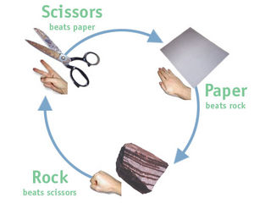

How about:

Robinson picks rock

Friday picks scissors Now game of Chicken

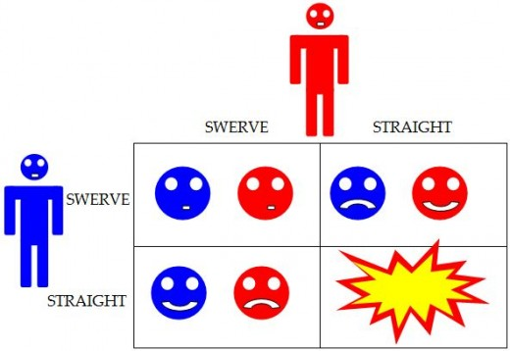



Suppose red person can convince blue person that he is totally OK with both players playing "straight" and smashing into each other. Then blue will play "swerve," seeing that red will play "straight." In a game of chicken, reputation for being crazy helps you win.



Application to

2013 debt ceiling negotiations

Perhaps can think of republicans were red player above, claimed fine to breach debt ceiling. Obama called their bluff.

Maybe more a hostage situation.

When Republicans in control of the Presidency (and both houses of Congress), the debt ceiling has been suspended (until March 2019).

Now that Democrats have the house, I don’t expect them to try to wield this weapon (even though it will be a big story in March because the deficit is starting to blow up).

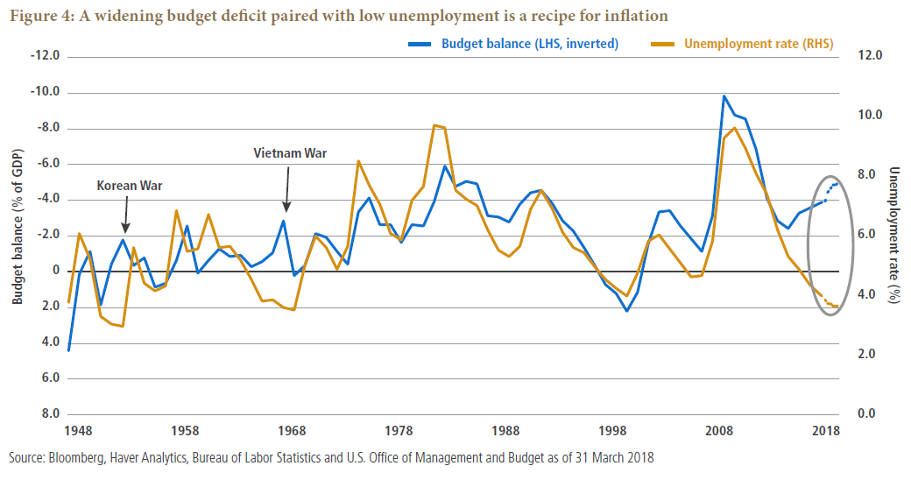

Next game of chicken on the horizon

Trump threatening to shut down the government to fund his wall.

After a shutdown starts, its more like a “War of Attrition”

Both parties lose, who blinks first?

Also, how about issue of China and US fighting about trade policy

* Both sides losing something right now
* Who blinks?