Lecture 14(i) Announcements

1. Final Exam: Fri, Dec. 14,
6:30 pm.-8:30 pm
- Makeup final on Tues. Dec 18
10:00 a.m.-noon
- REGISTER for makeup headgrader@gmail.com by Monday, Dec. 10, 4:00pm

Final OneStop Page (bottom of Canvas)

2. Platform Debate in discussion sections this week about immigration

(Discuss in class today. See also link at Canvas for reading to do before the debate.)
Inequality

0. Finish Immigration

1 Mention three policies to debate about this week

2. Wage incentives and labor migation

3. Capital Flows

Case 1: Agricultural Economy: Double population, then lower productivity because of diminishing returns to fixed land.

Case 2: Manufacturing
or Innovation Economy
(No fixed factor like land)

Plot average product as a function of the population:
$
L
Average Product

Case of increasing returns
Mechanisms:
- Scale economies
- Greater product variety
- Knowledge spillovers and information sharing (think Silicon Valley)

The theory explaining the existence of cities

And why South Dakota is advertising to get people to move there.
Watch clip
https://youtu.be/HrX8OTFSFZI

South Dakota is not thinking population inflows will do this:

S₂
S₁

$
L

D(fixed)

Rather, South Dakota thinking it looks like this or better:
S₂
S₁

$
L

D₂
D₁

Migrants increase the demand for labor (because they purchase things and can contribute to increasing returns)
So far have assumed migrants have the same skill. Now contrast
high skill versus low skill.
Start with
high skill migrants
Examples:
Albert Einstein
Sergey Brin
(Russia)
cofounder Google
Indra Nooyi(India) Chairman Pepsi
Ramon Laguarte (Spain new CEO)
Econ Dept, UMN https://cla.umn.edu/economics/people/faculty

Effects of immigration by high skill?
Suppose there is no increasing returns, no knowledge spillovers,and not shift in labor demand
wage
skilled

D_{s}
quantity
unskilled
quantity
skilled
wage
unskilled
S_{u}
w_{u}

S_{s}^{before}
D_{u}
w_{s}^{before}
w_{s}^{after}
S_{s}^{after}
Above doesn’t take into account shifts in labor demand.

But even if we allow for increases in labor demand, if there are no increasing returns, then immigration of high skill labor, fixing the quantity of low skill workers, will reduce wages of skilled workers relative to unskilled.

But still we get a beneficial
Fiscal Impact

High skill workers tend to pay more taxes then they cost in public service, so collectively we make money on them when they come.
Now take into account knowledge spillovers.

High skill immigrants can increase the productivity of other high skill workers.

High skill workers are the drivers of the knowledge economy.

Bad idea to tell Sergey Brin and Indra Nooyi to go back home!
Immigration into the U.S. is limited, and preferences are mainly given to relatives.

There are some programs to allow skilled workers in, but it is a small percent of 1,000,000 immigrants a year.

H-1B program: 85,000 spots for highly-educated foreign professionals.

Excess demand for these slots filled by lottery. (In 2014, applications were considered April 1, by April 5, 124,000 application submitted, stopped collecting.

Next look at low skill immigration
Without changes in labor demand
we get
wage
skilled

D_{s}
quantity
unskilled
quantity
skilled
wage
unskilled
S_{s}
D_{u}
w_{s}
S_{u}^{before}
w_{u}^{before}
S_{u}^{after}
w_{u}^{after}
Effects of low skill immigration

low skill wage: will fall relative to high skill wage
- decline will be relatively small if demand for unskilled labor is elastic because it is possible to outsource to foreign workers overseas, or to robots here

fiscal impact: Negative. Very low skill workers generally take out more in public services (public schools, health care), then they pay in taxes

contribution to knowledge spillovers?: Probably not, but maybe children of low skill immigrants will become educated and create knowledge spillovers.

Note: above focuses entirely on economic issues. There potentially also cultural factors and political factors for citizens of a country might vote to limit immigration.

Japan: limits immigration and population is declining (-0.2% a year). Ethnically homogenous population, there seems to be political support to keep it that way.

Policy Discussion

Background: DACA
“Deferred Action Childhood Arrivals”

Program set up by Obama in 2012, rescinded by Trump in Sept 2017

Program to “defer action” on undocumented immigrants who came here as children and didn’t commit any crimes. Gives them a quasi-official status

800,000 registered

President
Donald
Trump

Policy:
- Deportation force to expel existing unauthorized immigrants.
- Build wall+more barriers to unauthorized immigration
- Reduce existing legal immigration
  - Get rid of family based
  - Get rid of lottery for 50k

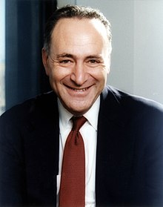
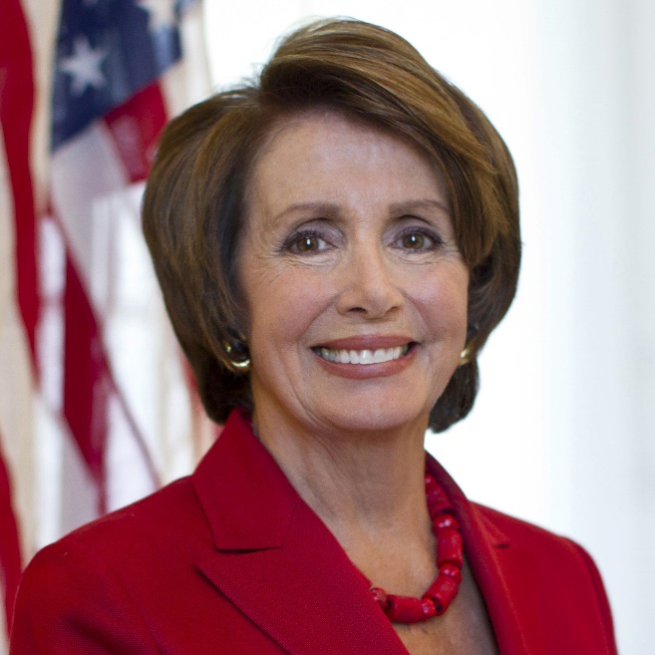

Nancy Pelosi (likely House Speaker come January)
Senate Minority Leader Chuck Schumer

Current Policy (gleaned from web sites)
- Reinstate DACA
- More generally go back to Obama policies

Back in the day presidential candidate Marco Rubio
(not later Senate candidate who just wanted to talk about the wall).

Platform
- Move away from immigration preferences based on relatives to preferences based on skill
- Somehow lock the door to new illegal immigration. Then integrate the 12 million undocumented immigrants already here with a drawn-out process that doesn’t use the word amnesty.

“Gang of Eight plan” from 2013, which included Rubio and Schumer, was similar.

- For example, it proposed that we take away the 50,000 slots a year that U.S. gives away for the diversity lottery, and instead give them out on a merit-based system.

Migration and Wages
wage_{rich}

D_{rich}
Quantiy of Labor
wage_{poor}
S_{poor}
w_{poor}

D_{rich}
w_{rich}
S_{rich}
Quantity of Labor
Poor Country
Rich Country
Wage incentive to move
∆w = w_{rich} − w_{poor}
Supply of migrants will depend upon this incentive. Maybe looks like
∆w
Q
migrants
S_{migrants}

20

10

100

At ∆w = 0, no one moves because of attachment to family.

Need the differential to get to
10 in this example before inducing migration.

Suppose the wage difference is $20, then equilibrium migration is 100.

Now suppose the rich country imposes costs, making it harder to get in. (Trump’s wall.)
Suppose have to pay $10 to a smuggler to get in. What happens to immigration?

But then what happens if the wage difference goes above $20?
Let’s talk about the refugee crises throughout the world. Suppose the supply of migrants looks like this:

∆w
Q
migrants
S_{migrants}

20

10

100

Imposing barriers obviously a bad idea. Get humanitarian disaster, and number of migrants is unchanged.
But suppose it looks like this, and there are no barriers….

∆w
Q
migrants
S_{migrants}

20

10

Capital Flows
Like people, capital will try to move to seek the highest returns.

Usually easier to move capital then people.

Suppose a small open economy.
Takes a given a fixed global rate of return on capital.

What happens when the country taxes capital?

In particular, what happens to the marginal product of capital?

In equilibrium, what happens to the marginal product of labor?

Compare all of these answers with a closed economy.

