Lecture 14(ii) Announcements

**1. Final Exam**: Fri, Dec. 14, 6:30p.m.-8:30

* Makeup final on Tues. Dec 18 10:00a.m.-noon
* **REGISTER** for makeup [headgrader@gmail.com](mailto:headgrader@gmail.com) by **Monday, Dec. 10, 4:00pm**

**Final OneStop Page (bottom of Canvas)**

**2. Platform Debate in** discussion sections this week about immigration.

(See link at Canvas for reading to do before the debate.)

Inequality

1. Determination of Wages

2. Increase in the skill premium and skill-biased technical change.

3. The economics of superstars

4. Henry Ford and unskilled-biased technical change

5. Unions

Determination of Wages

What has happened to Average Real Wages over time in the United States? (Real Wages means wages adjusted for inflation.)

Before looking at the table, let’s define average Labor Productivity as Total Output in a year divided by Total Hours Worked

Now look at the growth in average wages and the growth in average labor productivity

Table 2 in Chapter 18

Productivity and Wage Growth

|  |  |  |
| --- | --- | --- |
| Time Period | Growth Rate of Labor Productivity | Growth Rate of Real Wages |
| 1960-2015 | 2.0% | 1.8 |
| 1950-1973 | 2.7 | 2.7 |
| 1973-1995 | 1.4 | 1.2 |
| 1995-2015 | 2.1 | 1.8 |

Clear pattern here that wage growth is associated with productivity growth.

What is the source of labor productivity growth?

Main source: technological change.

Update: Recent work highlights the decline in labor share.

Let’s look at work by Minnesota economics professor

Loukas Karabarbounis

That is what is going on with average wages. Next, let’s discuss differences in wages across workers.

First factor

Compensating Wage Differentials

People with the same skills tend to get different pay if they work at jobs with different characteristics. More dangerous, unpleasant jobs tend to get higher pay (everything else the same.)

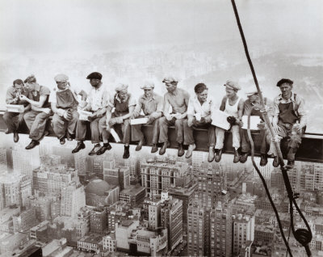

These guys probably get a little extra

Pay in North Dakota during the Bakken Oil Boom?

$80k year to drive a truck?

Why is this a compensating differential?

Second factor:

Workers differ in the amount of human capital they have acquired (that is skills/education)

Workers with more human capital tend to get higher wages.

Next the skill premium:

Define Skilled workers as college and above,

unskilled as high school educated, we showed that the skill premium

Table 1 in Chapter 19

($1,000 at 2014 prices)

|  |  |  |
| --- | --- | --- |
|  | 1974 | 2014 |
| Men |  |  |
| High school | 53 | 47 |
| College only | 75 | 86 |
| Skill premium | 42% | 81% |
|  |  |  |
| Women |  |  |
| High school | 30 | 33 |
| College only | 41 | 59 |
| Skill Premium | 35% | 71% |

(Note prices in 2014 were 4.8 times as high as in 1974. 1974 high school pay in 1974 dollars was 11k. The 53k above is 53k=4.8×11k)

Possible ways that demand

for skill has gone up relative to demand for unskilled labor.

Will go through two factors,

1) Skill-Biased Technical Change

2) globalization

Both matter, but we won’t settle anything today about the relative importance of the different factors.

Then dicuss an additional factor, decline in unions not based on shifts in demand and supply.

Factor 1:

Skill-Biased Technical Change

New innovations are complements for skilled labor, but substitute for unskilled labor. Impact on demand?

Fact: Share skilled increased

quantity

unskilled

quantity

skilled

wage

unskilled

wage

skilled

So graph must look like:

wage

skilled

D2014

quantity

unskilled

quantity

skilled

wage

unskilled

S1974

S2014

53

47

S2014

S1976

D1974

D2014

75

86

D1976

To understand skill-biased technical change, think about the invention of a robot that can spray paint a car or tighten a bolt on an automobile assembly line.

(a) The robot is a substitute for the unskilled worker on the assembly line.

(b) The robot does not do the creative work of designing the car. The skilled worker continues to do that job. The skilled worker designs the car and the robot builds it. In that way, the robot complements the skilled worker.

As another example, think about the further

development of web-based teaching. This

complements the skill of Greg Mankiw (our textbook author) as he can now leverage up his skill to potentially teach tens of thousands of students in economics classes across the country.

In fact, let’s ask Professor Mankiw to teach our class for a minute.

(Play clip from previous online version of the texbook. More on Mankiw getting cut out of current online version below)

(Actually, only have

<https://www.youtube.com/watch?v=ZwgG565ZsXw>

Mankiw explains how technological change is increasing salaries of the top basketball players. He could just as well have explained how this factor is increasing his own share of the pie. Online education is getting better and he gets a piece of the action.

The issue of how the internet (and communications technology more generally) impacts the return to being the best is called the

Economics of Superstars

Example: Suppose there is no internet, television or radio. If you want to hear someone sing, you have to hear them sing live. The very best singer in the world will be limited in how much he or she can earn: only what the best singer can charge from having people listen at a live concert. The 2nd best, the 3rd best, the 100th best singer probably won’t make much less than the 1st best, because the 1st best can’t really go around the world and give everyone a live concert.

But now think about what happens when new technologies (like recorded music) emerge that make it possible for the best singer to sell music to everyone. No one will be interested in listening to the 100th best anymore. Things move to a case where 1st best gets everything and 100th best nothing. (Winner take all.)

We will talk about widening inequality even at the top of the income distribution (the “have mores” pulling away from the “haves” and the “Economics of Superstars” is one explanation.)

Interesting to contrast the recent trend of “Skill Biased Technical Change” with the trend earlier in the 20th century.

Skilled worker at that time: include skilled craftsman who has learned a trade after a long apprenticeship.

Unskilled worker: Hands and arms connected to a strong back.

Technological change at time (Henry Ford’s assembly line) Take unskilled worker and put him on an assembly line. Up to speed in a few days. Here unskilled-biased technical change. In this period there was a decline in the skill premium.

Longer Term Trend (percent return per year of schooling) for



Can see in that in 1910, the return for an extra year of schooling was 15% and this fell to 8% in 1950.

Ford assembly plant in St Paul closed Dec. 2011

Here is a picture circa 1935

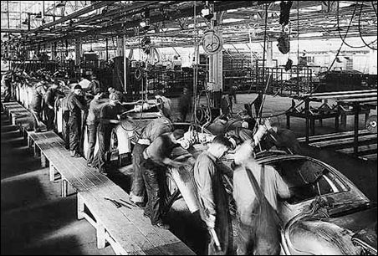

These unskilled workers are being replaced both by machines operating in the U.S. and low skill workers in other countries

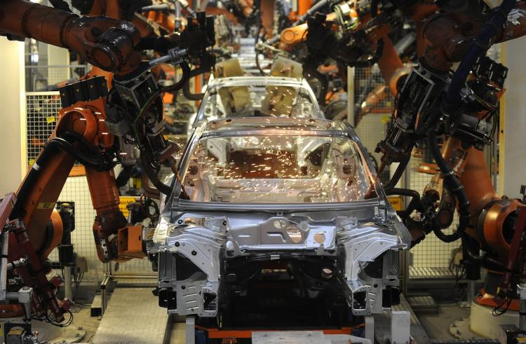Auto factories today

Still manufacturing many things in this country, but employment is way down because machines have replaced assembly workers

The next frontier: computers replacing jobs formerly done by high skilled workers. (Artificial intelligence read law cases, x-rays....

or

....writing economics papers?

Factor 2: Expansion of trade and immigration.

Why should that raise the skill premium in the U.S.?

In the United States, the ratio of skilled workers to unskilled is quite high relative to the rest of the world. With an expansion of trade, we tend to export goods with high skill content (e.g. pacemakers and high tech goods) and import goods with low skill content (like hand sewing of

sneakers). With an expansion of trade, the demand for unskilled labor declines in the U.S. This happens because of the increased availability of substitute products made by the vast number of unskilled workers throughout the world. With an expansion of trade, the demand for skilled labor tends to increase in the United States. As the United States specializes more in high tech and other industries that emphasize creativity, demand for skilled labor goes up.

Next: a contributing factor not based on shifts in demand and supply

Decline of Unions

Unions have declined significantly over the past 30 years. Production (or "blue collar") jobs are much more likely to be unionized than "white collar" jobs like management

In the 1950s and 60s, when the skill premium was the lowest, the percent unionized was the highest.

What do unions do?

Now watch clip of “Mike Brandl”

“concept clip” of textbook, “Unions” who has replaced Mankiw on textbook clips.

Not so great.

Better stick with the classroom model for now.

Union in Econland:

Remember S1’s derived demand for Labor from Lec 14(i), when the price of a widget was $2?

Wage

$



Labor

Demand

Units of Labor (days)

Suppose the units of labor are “Day”

Suppose the competitive price of labor is $10 a day. Then S1 will demand 8 days of labor.

Now suppose the plant is organized by “WWI” (Widget Workers International)

Suppose union negotiates a wage hike to $20 a day but firm still in charge of running the plant (and picking employment size)

The firm will respond by having ____workers in the plant each day.

Suppose the 8 workers initially in the plant share the reduced work.

If they workers take off every one day out of very four days, there will be 6 workers in the plant every day, which is what the firm demands at a wage of $20.

Average take-home pay: = (3/4)*$20

= $15

And one day off out of four!.

Of course the widget workers love this!

Economic Effects

1) Quantity of Labor

as with any monopoly, predict lower quantities (get get weight loss from too little output)

2. Inefficient Production

“Featherbedding”

work-rules to increase quantity of labor needed to do a job.

(as unions have been squashed, currently much less featherbedding then before.

3. Transfer of surplus

Union wage premium:

average about 15 percent Let’s look at a graph of the fraction workers in the U.S. represented by Unions



Source: Freeman, Richard, “Spurts in Union Growth: Defining Moments and Social Processesm: NBER Working Paper No. 6012, April 1997

Observe the steady decline since the maximum point of 35% in 1950.

As of 2017: union rate is

10.7% (membership share)

11.9% (coveraged by contract

membership<coverage since workers can usually choose not to be a member (but usually still required to pay union dues, unless they live in a “right-to-work” state.)

Private Sector 6.5% (covered)

Public Sector 37.9% (covered)

Lots of factors underlying decline:

(1) Shift of industry composition from manufacturing to services

(2) Within industries from blue collar to white collar

(3) within manufacturing and blue collar, a shift from union firms like GM and Ford, to nonunion firms like Toyota and Honda (companies not around in the US back in 1950s).

Once a union gets into a plant rare to get out. Volkswagen had plant in PA in 1970s, was unionized, but closed.

Now back again in Tennesee, but union not getting in.

(4) Change in legal environment

* Harder to organize (firms can do things to campaign against unions that would be called an unfair labor practice in an earlier day).
* There is now even a right-to-work law in Michigan!

Mention my 1998 study on location of manufacturing and right to work laws. In 1998 this what the map looked like:

See Holmes (2000), *Regulation*

*http://object.cato.org/sites/cato.org/files/serials/files/regulation/2000/4/holmes.pdf*