Lecture 1(i) (week 1, part i)

Welcome to Econ 1101!

Laptop or smart phone handy in recitations this week (but not required)

My office hours:
Wed 1:30-3:25

Office: 4-135 Hanson Hall

First order of business:
Common Evening Exams

Midterm 1.
Mon. Oct 8, 7:00-8:00 pm
(makeup Wed, Oct 10, 4:00 pm

Midterm 2
Mon. Nov. 12, 7:00-8:00 pm
(makeup Wed, Nov 14, 4:00 pm)

Final Exam
Fri: December 14, 6:30-8:30 pm
(makeup, either Tues or Wed., Dec. 18 or 19, exact day TBA)
If you can document a conflict with a Monday midterm, you can take the Wed. makeup.
Makeup Registration Deadline:
Monday one week prior to reg. exam
Email headgrader@gmail.com

(Include in your signature line:
- Student ID
- x500 username

x500 = Univ email minus @umn.edu

If you can document a conflict with both the regular time and the makeup (if you are sick that week), we will reweight your other midterm and the final, there is no makeup makeup!

If you miss both regular midterms and both makeup midterms (if you go 0 for 4), you need to take an incomplete or drop the class.

Course Information is at
course canvas site.
(Can get there from myu)

Read the syllabus.
This is a large operation (1300 students and 9 lectures), so to be consistent we stick to the syllabus.
Homework due online
Tuesday evening, 11:45pm c.s.t.
(Check the time zone setting at Aplia!)

Late homework not accepted.

To accommodate illness and other special circumstances, we drop 2 homeworks.

(Don’t need to tell us which ones you want to drop. Computer will select the 9 highest scores.)
How the class is going to work

- Lecture is the main deal.
  - Text is a complement, not a substitute.
  - The overheads from lecture will be posted at Canvas after class.
  - A preliminary version (with blank spots to be filled in) is posted by midnight before lecture.
- Reading Assignments
  - Text
  - Outside Readings (6) at Canvas

- Recitation
  - Small group activities
  - Ask questions!!!

- Forum for Student Questions (at Canvas)
  - A place to post questions
  - I will look at it several times a week.
  - Can also get answers from fellow students
  - Also: Economics in the News
- Homework
  - Cards are stacked in your favor (3 tries...)
  - But still have to make a good effort get something close to the full credit (20% of course grade).

- Exams
  - Multiple choice, computer graded.
  - Look at old midterms at Canvas.
- Office Hours
  - Wed 1:30-3:25
  - After class
  - Canvas Forum
Aplia

- Homework done online at aplia.com
- Need to pay for an account. :(
  - $112.65 Bookstore bundle: (aplia, hard copy text+online text) Don’t lose Code

- Follow instructions at Canvas for picking your Aplia section

- It you try to buy Aplia directly it costs $120, no hard copy of the book,

The class is a “two-for-one”

1. Social Science Core

2. Global Perspectives

As a Social Science Core, it is important to explain

- how this course contributes to a liberal arts education

- how economics relates to the broader social sciences
A Liberal Art Education Provides General Skills

Yes economics is essential for those who will work in business or policy spheres. Beyond career skills, economics
- Develops tools students can use to satisfy curiosity about social phenomena that have big impacts on their lives.
- Teaches a logical way of thinking, with broad applicability throughout social science.
- Helps students understand issues at stake in some of the great policy debates of our time.
Global Perspectives

The entire focus of the class will be beyond our borders. When the U.S. makes an appearance, it will be in its role in the global economy. In particular we will address:

1. Global Externalities and Climate Change

2. International Trade and its Impacts

3. Intellectual Property Protection in the Global Economy

4. Globalization, Inequality, and International Migration
You can see the “two-for-one” when you look at the problem sets.

1) You need to manipulate raw data and you will be using Excel to do this, the kind of thing you need to be doing for a social science core.

2) This data will always be from a global context. And will shed some light on one of the four issues above.

Textbook Economics
Your Book:
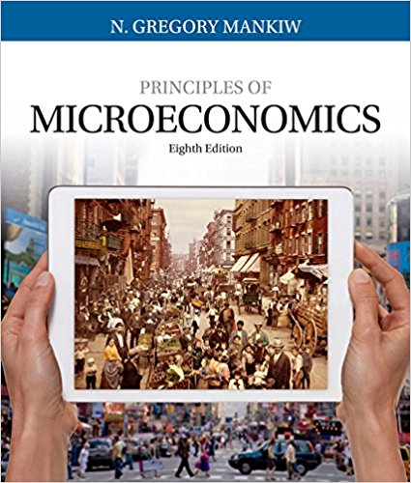

8th Edition (2017)
List Price $249
Amazon Discount Price $203
Amazon Rental Price $35
Used copy from $122?

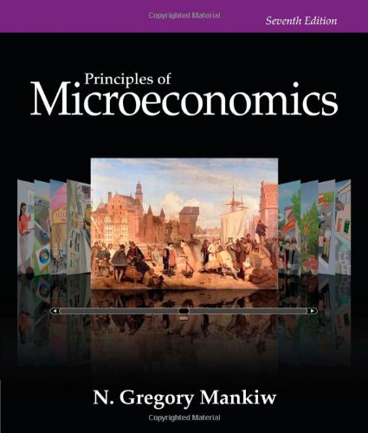

7th Edition (2014)
Amazon new (3 years ago) $226
Amazon new (now) $130
Used: from $23

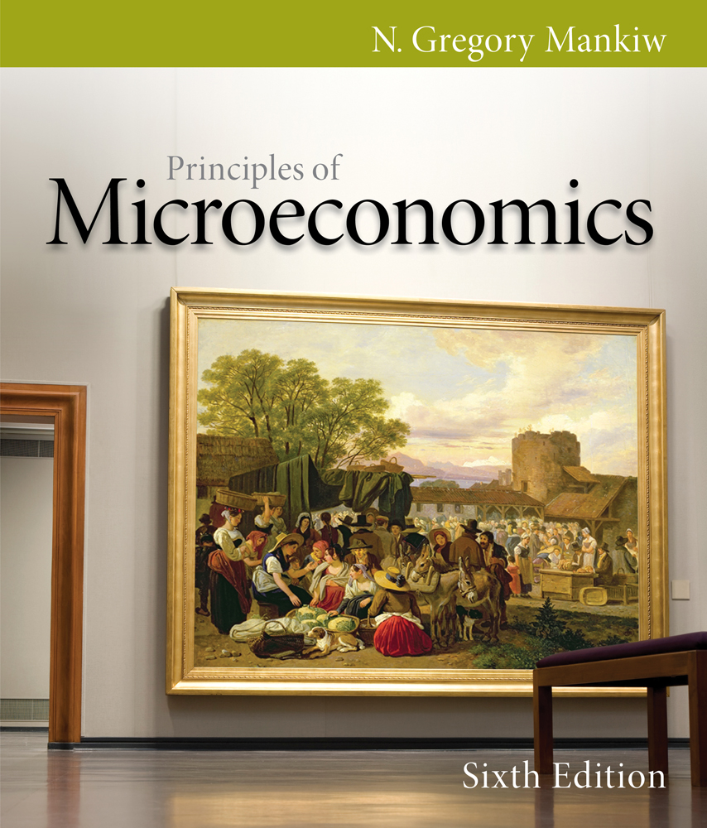

6th Edition (2011)
Original List: $227 (out of print)

Used: from $6.36

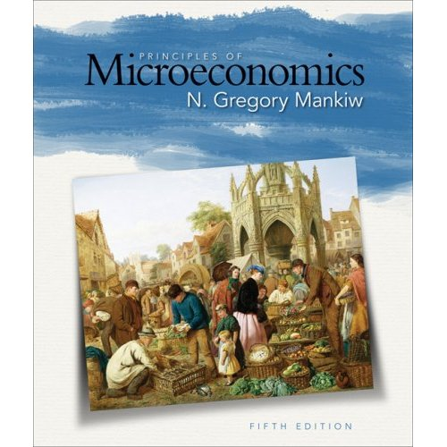

5th Edition (2009)
Original List $175 (out of print)

Used: from $8.99
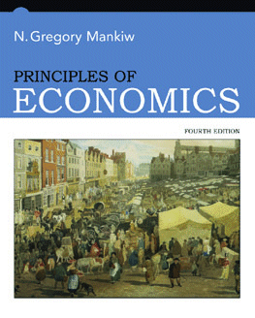
4th Edition (2007)
Original List Price $111
Used: $6.99

And in what way are the new editions better?
The pictures! (Text is the same)

3rd Edition:
Boring Old Male Professor with Whiteboard
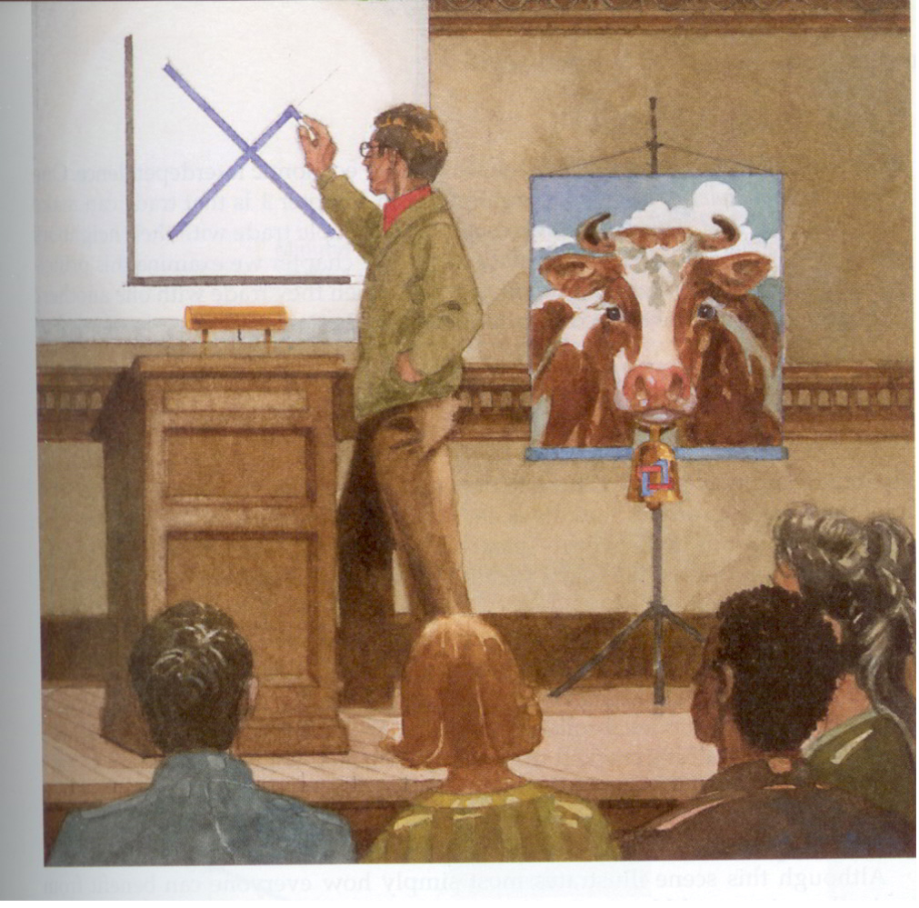

4th Edition upgraded to:

Female Professor with Powerpoint!

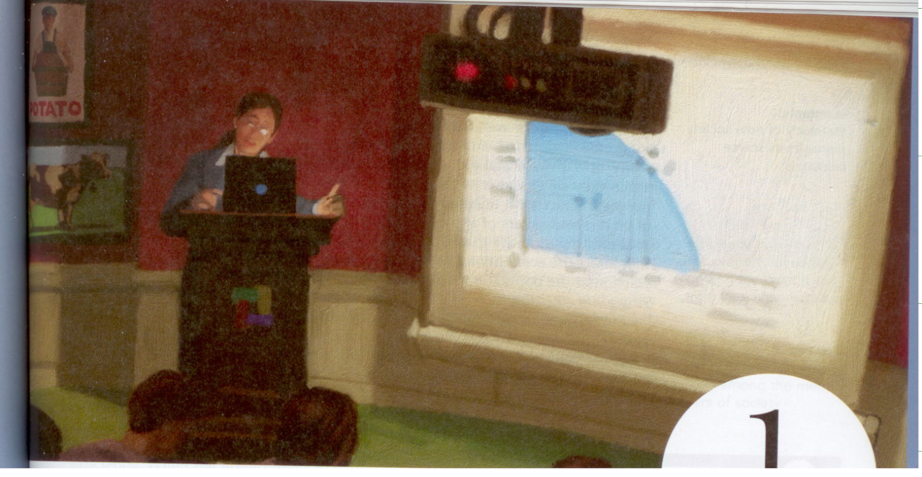
Note: cow still there.

5th Edition upgrade to:
Cool Female Professor
Plus Students Get Laptops!

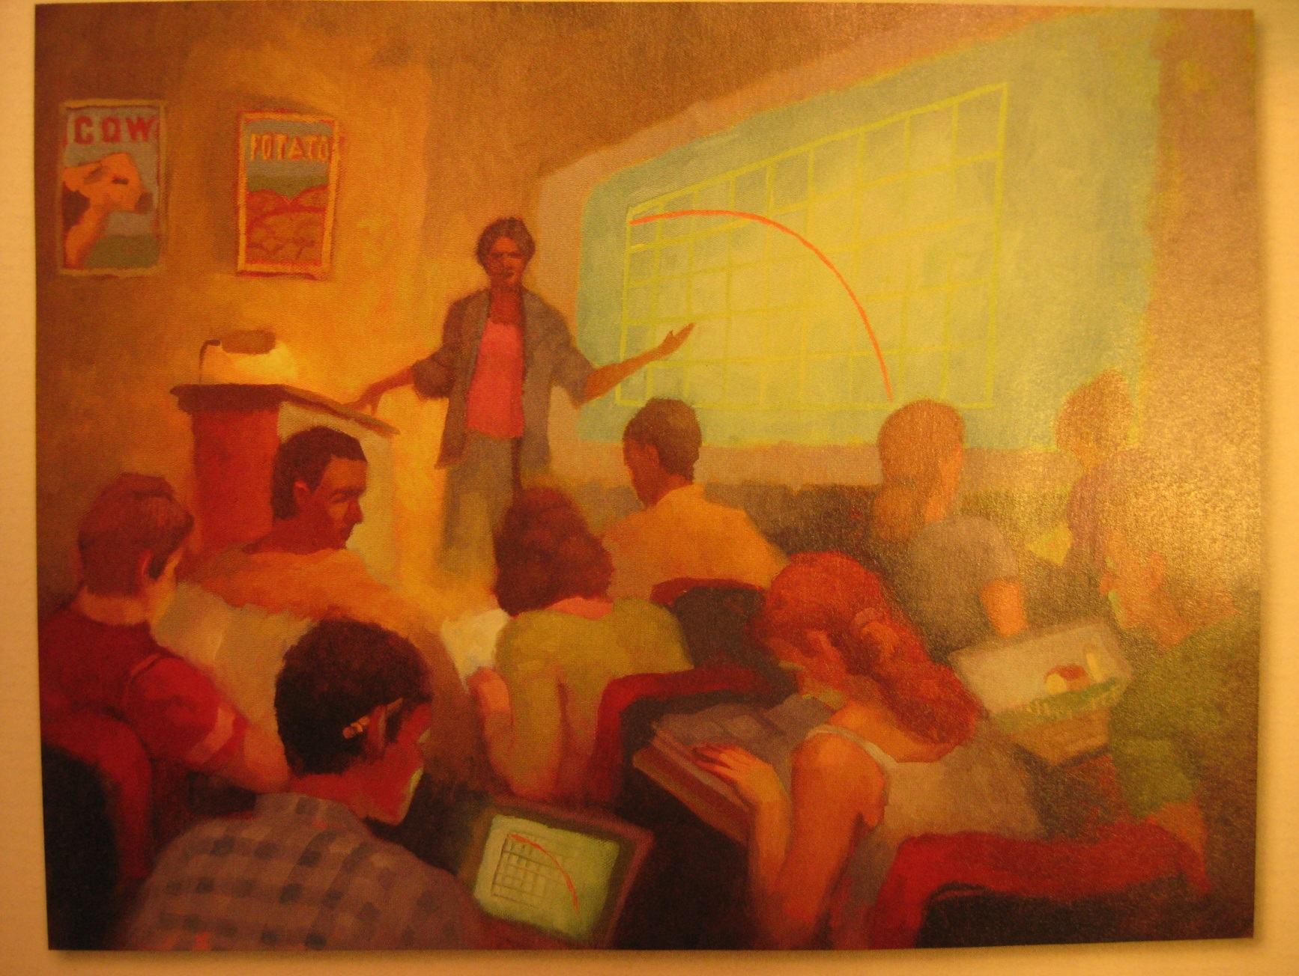
And still get cow. I couldn’t wait to see what technological advances there would be for the 6th Edition.

6th Edition
What? No technological progress?

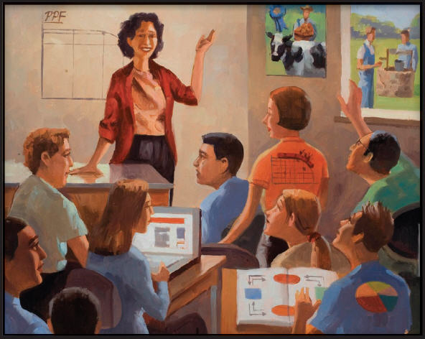
This is an example of

Technological Stagnation

With the 7th edition ....

.... students finally got iPads!

(Students still get a cow,
but now also get a roller coaster!)
But what about you?

What technological advance do you get?

Are you ready?

8th edition:
The picture is an iPhone!
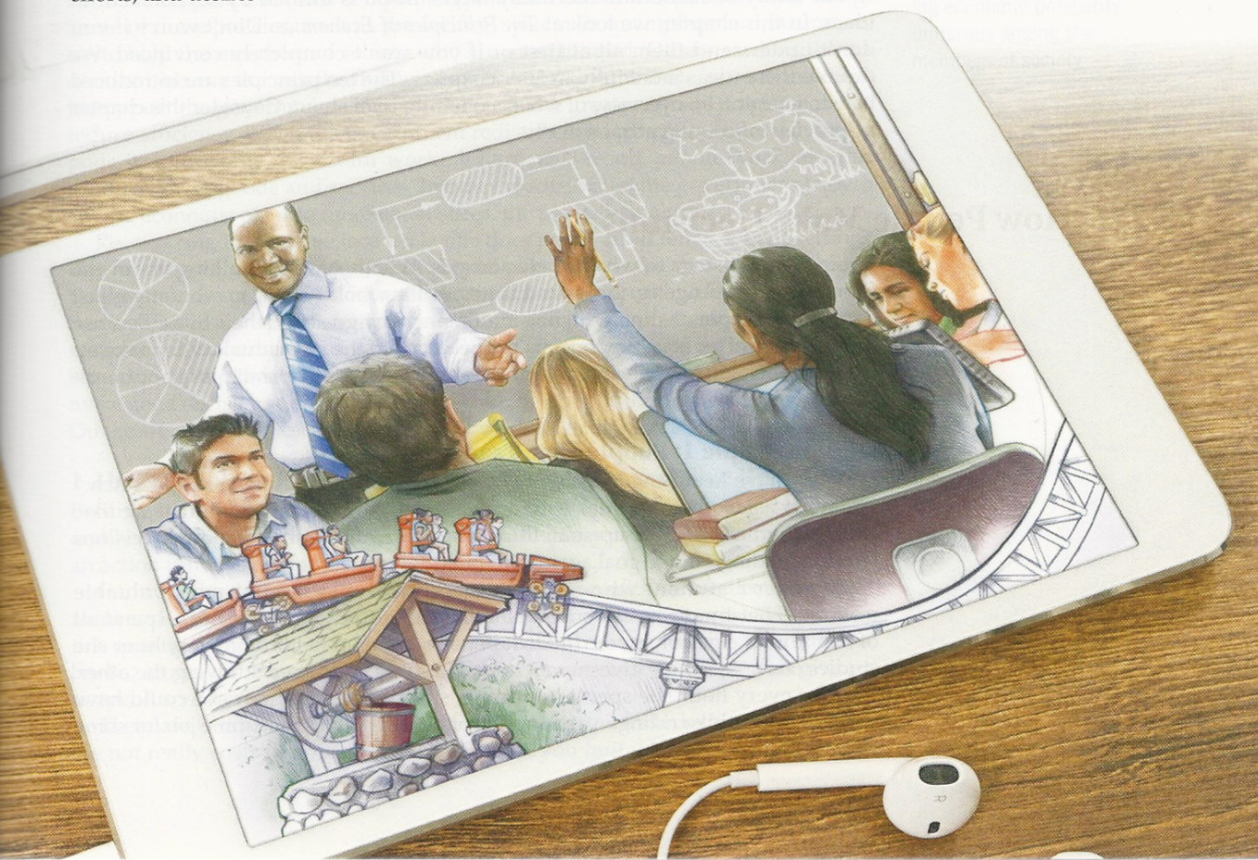

Lessons from textbook Industry

Lesson 1. Durable Good
- Like a car (not like a burrito)

- New edition comes out, sell to everybody first semester. Students sell them back to the bookstore and after the first semester used books drive down new books sales.

- Unlike a car, consumer needs a book for a short time.

What is a book publisher to do?

Answer: Kill off the used market.

Strategy 1: New edition (every 3 years) Most importantly, change page and problem numbers.

Strategy 2: Bundle content, like online homework, so payment is mandatory.

Strategy 3: Mutilate books when the opportunity arises. Like for you. (For our bundle: the publisher incurred higher costs to mutilate our hard copies...and kill off resale potential)
Lesson 2: Demand for Textbooks is Inelastic (relatively insensitive to price). So there is an incentive for firms to set a high price

For students, price of textbook a small part of the much larger cost of being in college . So students (or parents) pay the high prices so as to not mess up the investment.

Lesson 3: Moral Hazard!
Incentive Problem for Professors
(Don’t pay for the books themselves. Like doctors prescribing medicine not ordering generic versions of drugs.)

