Lecture 1(ii)

Announcements

1. HW1 due Tues 11:45 pm c.s.t

at Aplia.

2. Should have found the reading assignments for this week on Moodle. Textbook Ch 1,2 and Reading 1 (covering today)

3. Large Lectures MWF 9:05&10:10

Next Friday, we will have an experiment during class time. Don’t come to class, stay home (or anywhere on campus) and log into Aplia.

Other Lectures: Your instructor will announce time of experiment.

Lecture

1. Auctions: A “Warm-Up” to Supply and Demand

(and a few experiments)

2: Wholesale Electricity Auctions in the United Kingdom

3. Shifts in Demand and Changes in the Auction Price

1. Auctions

* An important form of market exchange
  + treasury bills
  + cell phone spectra (recent auction for unused TV spectrum reallocated to cell phones raise $20 billion).
* And relatively easy to see how they work (so good warm up)
* Let’s discuss a few types and and illustrate them with experiments.
* Can be single-sided where just one side of the market submit bids
  + Example just buyers submit?
  + Example where just sellers submit?
* Can be double-sided where both sides submit.
  + Experimental auctions next week one example.
  + UK power auctions
* Can be
  + Pay-as-bid (if bidder wins, price is as bid)
  + Uniform Price (bids determine who wins, but price is same for all winning bids. More on this below)

Do a few experiments. Illustrate:

1. that economists sometimes do research through experiments
2. get you ready for the experiments next week
3. get you ready for the way things work in “Econland” that is coming

Experiment I: single-sided, sellers submit bids, sealed bid, pay as bid.

A buyer needs a book

* + - There are three sellers, i=1,2,3
    - The buyer has a reserve price (won’t pay any more than this)
    - w(i) is the wholesale price of seller i (seller's cost)
    - seller i submits price p(i) (sealed bid)
    - sale goes to the lowest bidder at this bid (if below reserve price)
    - If bidder i gets sale, has profit of

p(i) − w(i)

A word about currency...

This is a global perspectives class, so the currency is Euros.

Let’s ask Google the exchange rateAuction outcome:

Buyer reservation price €80

Seller costs:

w1 = € w2 = € w3 = €

Bids:

Winner is Bidder

Selling price is winner’s bid of

Profit to Bidder ___ is

Foreign exchange desk here today.

Better rates than at airport!

A Tradeoff: What are the costs and benefits of submitting a low bid?

Experiment 2:

Role of competition Let’s set up a situation where bidders know each others’ costs)

Costs w1 = w2 = w3 =

(i) Sale price with three bidders?

(ii) Sale price with one bidder?

Experiment 3:

Role of Collusion

Set up similar to Ex. 2 with three bidders.

Are there three people in the class who are friends. (Or maybe would like to be friends....)2. Electricity Auction in UK

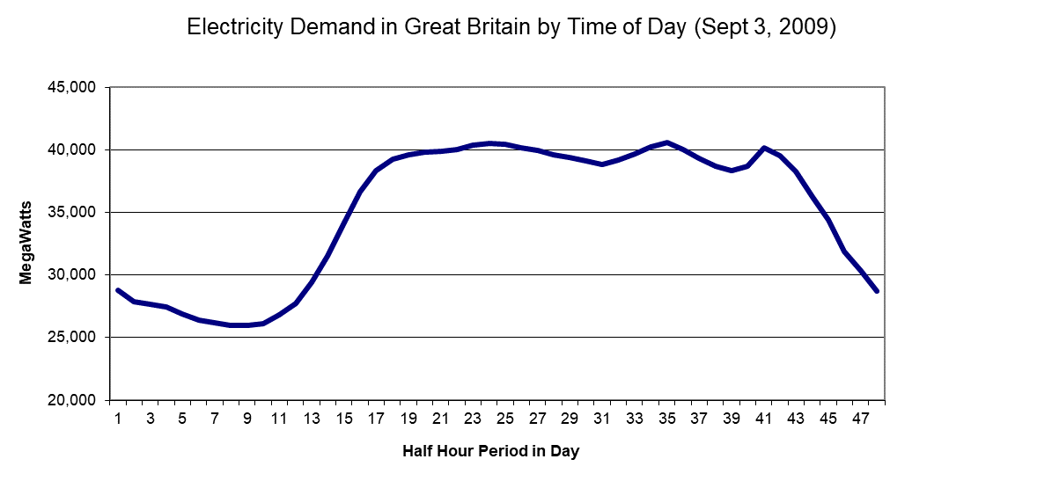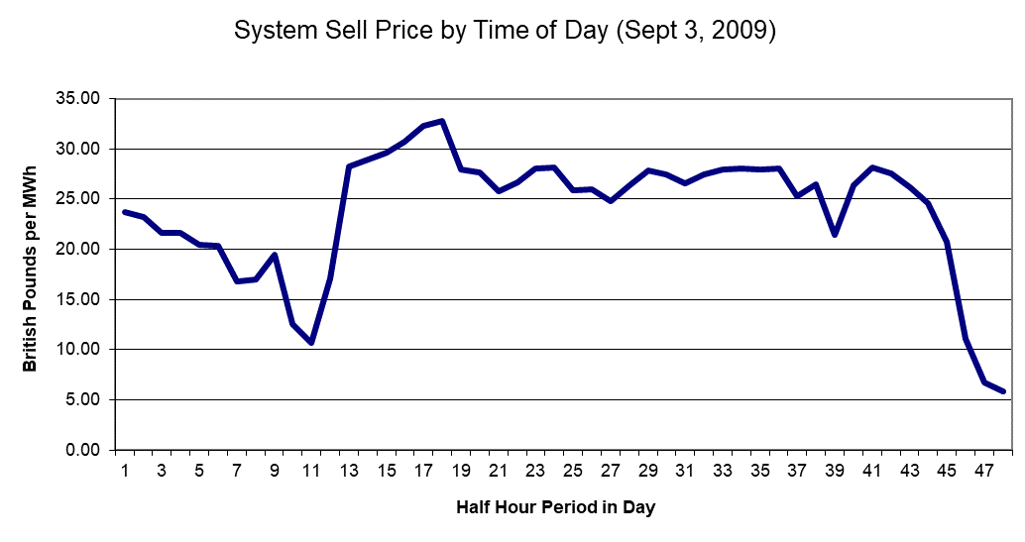

Independent System Operator

1. Receives offers to sell from Suppliers

“I will sell 10 Megawatt hours for £25 from 11:00-11:30…”

2. Sees forecast of demand

3. Picks P, Q and Who

Rules: Sort bids by price, set price equal to last need to meet demand. Use uniform price auction format in this example.

**Hourly Electricity Market:**

**Friday, 16:00**

**Buyer**: submits quantity demanded (Qd=6)

**Sellers**: submit bids

|  |  |
| --- | --- |
| Seller Name | Sell Price for 1 MHd (£ per MWh |
| S1 | 30 |
| S2 | 5 |
| S3 | 50 |
| S4 | 10 |
| S5 | 20 |
| S6 | 25 |
| S7 | 5 |
| S8 | 10 |
| S9 | 50 |
| S10 | 15 |

First task of ISO (Independent System Operator): Sort Bids (lowest to highest

|  |  |  |  |
| --- | --- | --- | --- |
| Rank | Seller Name | Sell Price | In? |
|  |  |  |  |
|  |  |  |  |
|  |  |  |  |
|  |  |  |  |
|  |  |  |  |
|  |  |  |  |
|  |  |  |  |
|  |  |  |  |
|  |  |  |  |
|  |  |  |  |

First task of ISO (Independent System Operator): Sort Bids (lowest to highest

|  |  |  |  |  |
| --- | --- | --- | --- | --- |
|  | Rank | Seller Name | Sell Price | In? |
|  | 1 | S2 | 5 | x |
|  | 2 | S7 | 5 | x |
|  | 3 | S4 | 10 | x |
|  | 4 | S8 | 10 | x |
|  | 5 | S10 | 15 | x |
| Qd = | 6 | S5 | 20 | x |
|  | 7 | S6 | 25 |  |
|  | 8 | S1 | 30 |  |
|  | 9 | S3 | 50 |  |
|  | 10 | S9 | 50 |  |

Can Do it with a Graph:

P

£



Q

First task of ISO (Independent System Operator): Sort Bids (lowest to highest

|  |  |  |  |  |
| --- | --- | --- | --- | --- |
|  | Rank | Seller Name | Sell Price | In? |
|  | 1 | S2 | 5 | x |
|  | 2 | S7 | 5 | x |
|  | 3 | S4 | 10 | x |
|  | 4 | S8 | 10 | x |
|  | 5 | S10 | 15 | x |
| Qd = | 6 | S5 | 20 | x |
|  | 7 | S6 | 25 |  |
|  | 8 | S1 | 30 |  |
|  | 9 | S3 | 50 |  |
|  | 10 | S9 | 50 |  |

Can Do it with a Graph:

P

£



Q

What happens to price throughout the day?

Suppose seller bids the same.

D16

P

£



S

Q

Megawatt Hours

|  |  |  |
| --- | --- | --- |
| Time | Demand | Price |
| 4:00 (off-peak) | 2 |  |
| 10:00 | 4 |  |
| 16:00 (peak) | 6 |  |



Big idea here:

Price is high when demand is high.

If extra time, let’s look what is happening in the electricity market in the UK right now,

<https://www.bmreports.com/bmrs/?q=eds/main>

and in California

<http://www.caiso.com/Pages/TodaysOutlook.aspx>