Lecture 2(i)

Announcements

HW 1 due Tues 11:45 pm at aplia.com

Aplia experiments this week.

Times for large lectures:

001AL Fri 9:05-9:30 am

001MZ Fri 9:30-9:55 am

017AL Fri 10:10-10:35 am

017MZ Fri 10:35-11:00 am

Times for small lectures announced in class.

Note: just go to Aplia.com at the scheduled time. You can log on from anywhere on campus.

Lecture

1. More on Independent System Operator (ISO) and time of day pricing

2. Supply and Demand and Market Equilibrium

Economics about solving resource allocation problems

Last Class a special case: ISO

(Independent System Operator)

Determines wholesale price by time of day in United Kingdom

(also in California)

Rules: rank bids to sell (low to high)

Find last one in so quantity supplied equals demand

Price is bid of last one in

(uniform price auction)

So at the half-hour time slot starting at 16:00, if Qd=6, and given the bids we saw last class, remember how the ISO picks P, Q, and Who.

We Made a Table

|  |  |  |  |  |
| --- | --- | --- | --- | --- |
|  | Rank | Seller Name | Bid for 1 Mwh | In? |
|  | 1 | S2 | 5 | x |
|  | 2 | S7 | 5 | x |
|  | 3 | S4 | 10 | x |
|  | 4 | S8 | 10 | x |
|  | 5 | S10 | 15 | x |
| Qd = | 6 | S5 | 20 | x |
|  | 7 | S6 | 25 |  |
|  | 8 | S1 | 30 |  |
|  | 9 | S3 | 50 |  |
|  | 10 | S9 | 50 |  |

We plotted the bids

P

£



Mega Watt Hours

How we plot the bids: The lowest bidder bid 5, so put a dot at (1,5). There is a second bid at 5, so put a dot at (2,5). The third lowest bid is 10, so put a dot at (3,10). And so on.

Next we draw a line to represent the capacity that is available at that bid. Up to two units are available at a price of 5. But if demand is 2.5 units, we can get the first 2 units from S2 and S7 who bid 2, but to get another .5 units we have to bring in S4 who bid 10. So that is why the price jumps up to 10 right about a quantity of 2 .

Next we add in demand

Then we added demand

to the graph

D



S

Mega Watt Hours

P

£

System price = ₤20 per Mw hour

We can use this graph to see what the ISO will do. The system price will be where the demand line intersects the supply line.

Bidding Strategies

Suppose you are bidding in a uniform price auction. If there are many bidders and if you are not working together as a cartel, the best strategy is for you to bid close to cost (or your break-even level).

The reason:

1. With many bidders, the chance that you will be exactly the last one in who determines the system price is small. Mainly, your choice of bid determines whether you are in (your bid to sell is below the system price) or out (your bid to sell is above the system price.)

2. If you bid more than your cost, and the system price turns out to be higher than your cost, but lower than your bid, then you are out, even though you could have made a profit selling at that system price.

3. If you bid less than your cost, and the system price turns out to be below your cost but above your bid, then you are in. But the system price is below your cost so you lose money!

Bottom line: in a uniform price auction with many bidders, your bid determines whether you are in or out, but probably not what you get paid when you are in.

Class Discussion

Let’s go back to the example. Suppose the bidders in this auction are bidding their costs. Is this a good move on the bidder’s part?

Several students in the class observed that bidder S5 who put in a bid of 20, and who ended up being the last one in, could increase profit by raising the bid. If 20 is the cost of S5, and S5 submits a bid of 24.99, it will still be among the lowest 6 bids offered, and will still be “in.” But now the system price will be 24.99 instead of 20, and so profit will be higher.

This is a good point. But now let’s think about a situation where there are more bidders. These additional bidders will tend to fill in the space between the bid of 20 and the bid of 25. For example, suppose there is a bidder named S11 who submits a bid of 22. Now we can see that it would be a bad move for S5 to submit a bid of $24.99, because it won’t be among the lowest bids and won’t make any money at all. Instead it should bid $21.99. We can see that this is starting to get close to S5’s cost.

Experimental auctions this week

are Pay as Bid format, not Uniform Price.

Incentives are different here!

Don’t bid cost because that is what your payment will be if your bid is accepted.

Let’s go back to the part about not working together as a cartel.

If the bidders can work together as a cartel, of course they will want to submit higher prices than they would without cooperation.

Can make an argument that a uniform price auction is more vulnerable to manipulation because all you need to do is manipulate prices of the last unit in, which determines the price.

To act as a cartel with the pay-as-bid format, all the prices need to be manipulated, not just the last one in, and this can lead to suspicious behavior that may be likely to be caught by regulators.

Also, a sneaky way to get the price up is to withhold capacity. Compare:

S10 submits bid of 100

versus

S10 says generator has broken down

P, Q, and Who when S10 says

maintenance is needed

|  |  |  |  |  |
| --- | --- | --- | --- | --- |
|  | Rank | Seller Name | Bid for 1 Mwh | In? |
|  | 1 | S2 | 5 | x |
|  | 2 | S7 | 5 | x |
|  | 3 | S4 | 10 | x |
|  | 4 | S8 | 10 | x |
|  | 5 | S10 | 15 | x |
| Qd = | 6 | S5 | 20 | x |
|  | 7 | S6 | 25 |  |
|  | 8 | S1 | 30 |  |
|  | 9 | S3 | 50 |  |
|  | 10 | S9 | 50 |  |

Time of Day Pricing

For many suppliers costs don’t change throughout the day

* Oil, natural gas, coal turbines
* Nukes
* Hydro

If there are many such bidders and they are not colluding, we might expect bids of such suppliers not to change much during the day.

However, demand changes substantially throughout the day and this will lead to changes throughout the day in price.

The system price throughout the day

D16



S16

Mega Watt Hours

P

£

|  |  |  |
| --- | --- | --- |
| Time | Demand | Price |
| 4:00 early (morning) | 2 |  |
| 10:00 | 4 |  |
| 16:00 (peak) | 6 |  |



Electricity Demand in Great Britain

Sept 3, 2014

(MegaWatt Hours by Time of Day)

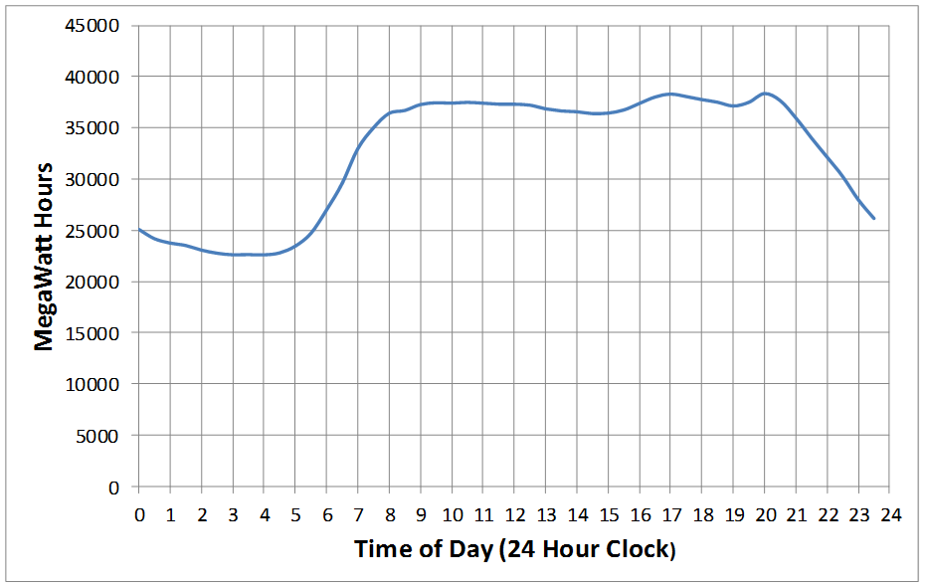

Reference Price of Electricity in Great Britain on Sept. 3, 2014

(British Pounds per MegaWatts)

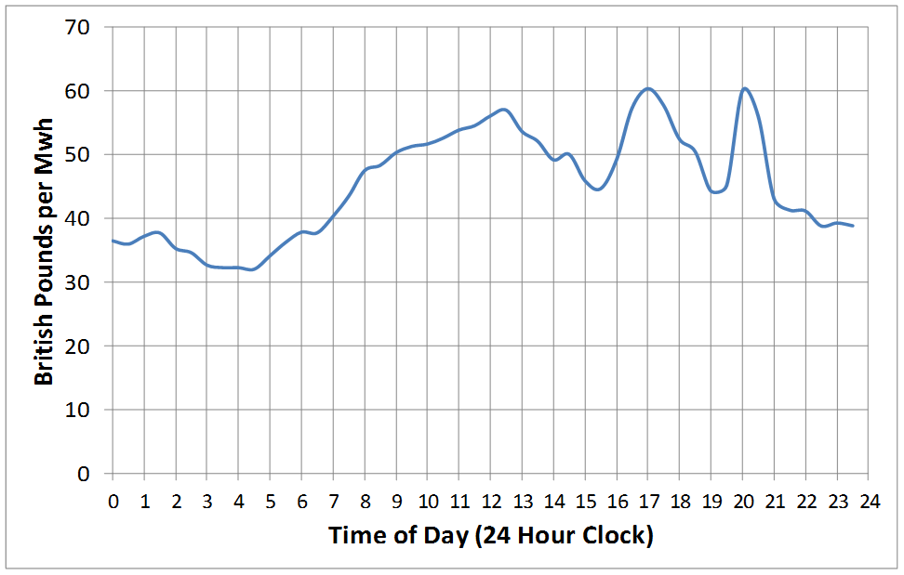

* What is something pretty useful about solar energy?
* Of course there are problems on cloudy days. But then what is pretty useful about what Elon Musk and Tesla want to do with batteries?
* What would happen if batteries became so good and so cheap that one could produce a one megawatt hour of electricity at 2:00 a.m. for use at 2:00 p.m. later in the say at low cost?
* But we are not there yet. Emergence of solar and wind causing a problem: driving out older technologies that are less green, but produce reliably.

”

In what we have been discussing, there is an ISO running things.

A Visible Hand at wheel.

(Or at least a visible computer program.)

Now we will develop Demand and Supply analysis and apply it to markets without equivalent of ISO

For certain markets will argue that that market behaves as though there is an ISO picking P, Q, and Who.

These competitive markets work as if guided by an Invisible Hand (Adam Smith’s term)

Start with:

Experimental Auctions This Week

No ISO managing things.

(It will be free-wheeling.)

Yet we will see the market will work as though there was an invisible hand at work.

Before giving other examples, let’s get a definition on the board.

Defn Competitive Market

A market in which there are many buyers and many sellers so that the behavior of an individual buyer or seller has a negligible impact on the market price.

i-Phone?

Corn?

Market For Corn

Quantity Supplied: amount sellers are willing and able to sell.

Depends upon the price of corn

Higher price: more farmers willing to plant corn

(Go back to UK auction market and look at supply. At higher price...)

Quantity Supplied depends on other things like inputs that we will discuss later.

(Go back to “supply” in the UK auction. What happens if oil prices increase....)

Quantity Demanded: amount buyers are willing and able to purchase.

Depends upon the price of corn (and other stuff we will discuss later.)

Higher price: quantity demanded is less.

Hypothetical Numbers

(that are easy to work with!)

|  |  |  |
| --- | --- | --- |
| Price | QS | QD |
| 0 | 0 | 8 |
| .50 | 1 | 7 |
| 1.00 | 2 | 6 |
| 1.50 | 3 | 5 |
| 2.00 | 4 | 4 |
| 2.50 | 5 | 3 |
| 3.00 | 6 | 2 |
| 3.50 | 7 | 1 |
| 4.00 | 8 | 0 |

Market for Corn



Equilibrium:

Market for Corn



Qe

Pe

P

Q

S

D

At P=2, QD = 4 and QS = 4

QD = QS so in equilibrium.

Case of Excess Supply



Qe

Pe

P

Q

S

D

Suppose P=$3: Out of equilibrium!

Case of Excess Demand



Qe

Pe

P

Q

S

D

Suppose P=$1: Out of equilibrium!