Lecture 3(iii)

Announcements

Lecture

1. What makes demand more elastic?

2. Income Elasticity

3. Widget Industry in Econland

Consumer Surplus

Producer Surplus

4. Pareto Efficiency

What Makes Demand More Elastic? Answer: All about substitution possibilities.

1. Long time horizon

(More time to switch to something else)

2. When products are defined more narrowly so there exist closer substitutes.

Look at Food

A)Price elasticity of food as a group is low (inelastic). So if all prices increase 10%, quantity falls less than 10% (so spending on food goes up).

B) But now suppose look at one kind of food, meat. Raise price of meat, price of other foods fixed...

C) Now look at raising price of Johnsonville Brats 10%

Income Elasticity of Demand



For Inferior Goods: 

For Normal Goods: 

Two kinds:

Necessity 

(Or income inelastic. Spending share falls as income rises)

**toilet paper…**

Luxury 

(Or income elastic: Sending share rises as income rises)

**vacation homes... and**

Health Care

(At country level)

Look at this data on health care spending as percent of GDP

(gross domestic product) for various countries

Data from, Uwe E. Reinhardt, Peter S. Hussey and Gerard F. Anderson, "U.S. Health Care Spending In An International Context," Health Affairs, 23, no. 3 (2004): 10-25 <http://content.healthaffairs.org/cgi/content/full/23/3/10>

|  |  |  |
| --- | --- | --- |
| County | GDP per Capita | Health  Spending Share |
| US | 35.2 | 13.9 |
| Switzerland | 29.9 | 11.1 |
| Norway | 36.4 | 9.0 |
| Germany | 26.2 | 10.7 |
| Canada | 28.8 | 9.7 |
| **Average Rich** | **31.3** | **10.9** |
|  |  |  |
| Hungary | 13.4 | 6.8 |
| Slovak Rep | 12.0 | 5.7 |
| Mexico | 8.9 | 6.0 |
| Turkey | 5.7 | 4.8 |
| **Average**  **Poor** | **10.0** | **5.8** |

So health care at the country level is clearly an income elastic good.

Richer countries tend to spend a higher share of income on health care.

Next we introduce a model that will we use to study how markets work.

As is standard practice in economics, the model will be fully specified. We will explicit about all the agents in the economy and how they behave. Widget Industry in Econland

Going to use this to examine the efficiency of competitive markets and the impacts of government policies.

Inhabitants: D1, D2, D3,….D10

S1, S2, S3, ….,S10

Only D people eat Widgets.

Each D person has a reservation value for one widget. Amount of dollars he would be exactly willing to give up to get one.

(Note: each D person can eat at most one widget)

Table of reservation values

|  |  |
| --- | --- |
| Name | Reservation price for one widget |
| D1 | 9 |
| D2 | 8 |
| D3 | 7 |
| D4 | 6 |
| D5 | 5 |
| D6 | 4 |
| D7 | 3 |
| D8 | 2 |
| D9 | 1 |
| D10 | 0 |

D1 indifferent between:

$20 and 0 widget

$11 and 1 widget

Connection to experiment last week

S people

* don’t eat widgets.
* but know how to make them
* get hungry from widget work

Cost to a S person to make one widget. Amount of dollars we have to give her so she is just willing to do it.

(Each S person can make at most one widget.)

Table of Costs

|  |  |
| --- | --- |
| Cost of one widget  (dollars) | Name |
| 1 | S1 |
| 2 | S2 |
| 3 | S3 |
| 4 | S4 |
| 5 | S5 |
| 6 | S6 |
| 7 | S7 |
| 8 | S8 |
| 9 | S9 |
| 10 | S10 |

S3 indifferent between:

$20 and making 0 widget

$23 and making 1 widget

Gather the Information Up

Reservation Prices and Costs for Widgets

|  |  |  |  |  |
| --- | --- | --- | --- | --- |
| Name | Res.  Price |  | Cost | Name |
| D1 | 9 |  | 1 | S1 |
| D2 | 8 |  | 2 | S2 |
| D3 | 7 |  | 3 | S3 |
| D4 | 6 |  | 4 | S4 |
| D5 | 5 |  | 5 | S5 |
| D6 | 4 |  | 6 | S6 |
| D7 | 3 |  | 7 | S7 |
| D8 | 2 |  | 8 | S8 |
| D9 | 1 |  | 9 | S9 |
| D10 | 0 |  | 10 | S10 |

Let’s plot this.

Marginal Cost: the cost of the next one in.

Marginal Reservation Price: The value of the next one in. (Could call that marginal benefit) 

Does this look familiar?

How about this from last week?

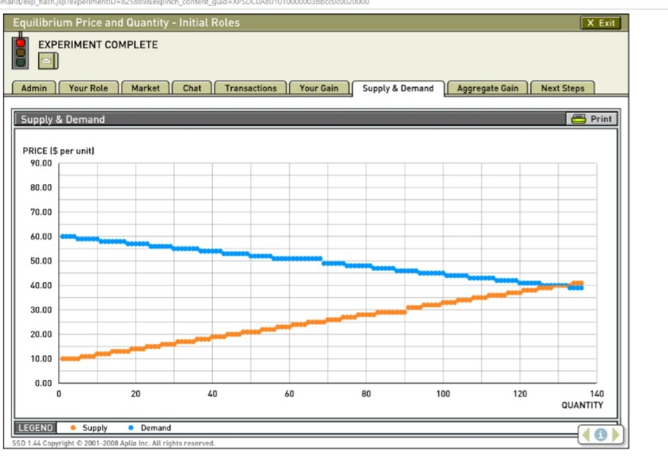

Suppose we set up a market economy in Econland

At P=3, who is willing to sell?

so QS is

So from Marginal Cost curve,

we get

At P=7, who is willing to buy?

So QD is

So Marginal Res. Price curve

we get

What happens when Econland is a Market Economy?

P: price of a widget

MRP is demand curve

MC is supply curve

* Q = 5
* P = 5
* S1, S2, S3, S4, S5 produce
* D1, D2, D3, D4, D5 consume

Market determines the P, Q, and who.

What are the Gains from Trade?

Consumer surplus of particular buyer

= reservation price – price paid

Producer surplus of seller

= price received – cost

|  |  |  |  |  |  |  |
| --- | --- | --- | --- | --- | --- | --- |
| Q | Res.  Price | price paid | CS | Price  rec. | Cost | PS |
| 1 | 9 | 5 | 4 | 5 | 1 | 4 |
| 2 | 8 | 5 | 3 | 5 | 2 | 3 |
| 3 | 7 | 5 | 2 | 5 | 3 | 2 |
| 4 | 6 | 5 | 1 | 5 | 4 | 1 |
| 5 | 5 | 5 | 0 | 5 | 5 | 0 |
| 6 | 4 | - | 0 | - | 6 | 0 |
| 7 | 3 | - | 0 | - | 7 | 0 |
| 8 | 2 | - | 0 | - | 8 | 0 |
| 9 | 1 | - | 0 | - | 9 | 0 |
| 10 | 0 | - | 0 | - | 10 | 0 |
| Total | |  | 10 |  |  | 10 |

TS = CS + PS

20 = 10 + 10

Consumer Surplus and Producer Surplus in Competitive Equilibrium



See in graph

Consumer Surplus

Area between demand curve and price line

Producer Surplus

Area between price line and supply curve

In Econland, demand and supply curves look like steps

In economy with lots of people, we won’t notice the steps, things will smooth out.



CS = Area of Triangle

= ½×5 ×5 = 12.5

PS = ½×5 ×5 = 12.5

TS = CS + PS = 25

Like this from last week:



PS at competitive price?

So that is market allocation

And the social surplus (or “pie”)

And the division of the surplus (“who get’s what slice”)

The next step is to examine the efficiency of the market.

Need a concept of efficiency.

The standard concept is

**Pareto Efficiency**

Vilfredo Pareto 1848-1923

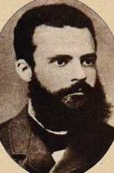

An allocation is Pareto Efficient if it is feasible and there is no way to make someone better off without making someone worse off.

or...The Pie is big as it can be. (If someone is to get a bigger slice, it can only come from someone else getting a smaller slice.)