Lecture 5(i)

Announcements

* Midterm Covers through Lec5(ii)
* Practice midterm at Canvas (look at it before recitation sections this week)
* Question and Answer Sessions
* Wed Oct 3: 4-5:30: Anderson 310
* Wed Oct 3, 7:30-9: Anderson 210
* Thur Oct 4 3:30-5 : Anderson 210
* My Office Hours This Week
  + Wed 1:30-3:25 (usual)
  + Thur: 1:30-2:30 (extra)
* Large Lectures (Wiley 175) cancelled this Friday.
* **Still have discussion sections!**
* Next Mon (Oct 8), go to evening midterm, 7-8pm **instead** of lecture. Room locations posted at Canvas
* Bring #2 pencils and University ID
* Don’t Bring: Calculators and Scratch Paper.

Lecture

1. More on tax rates:

“Broad Base” Tax Principle

2. Price Controls

Review important table from last class

|  |  |  |  |  |
| --- | --- | --- | --- | --- |
| Tax | Q | Revenue | Dead-wgt Loss | Dead-wgt loss per $ Tax Rev |
| 1 | 4.5 | 4.50 | .25 | .056 |
| 2 | 4.0 | 8.00 | 1.00 | .125 |
| 4 | 3.0 | 12.00 | 4.00 | .333 |
| 5 | 2.5 | 12.50 | 6.25 | .50 |
| 6 | 2.0 | 12.00 | 9.00 | .75 |

But a lot easier to understand with pictures, so let’s do that

$4 Tax



Tax

Tax revenue = 12

Dead weight loss = 4

**Tax revenue= 3 × DWL**

$2 Tax



Tax

Tax revenue = 8

Dead weight loss = 1

**Tax revenue = 8 × DWL!**

We know all about widgets, but...

* Suppose in Econland there also smidgets!
* Suppose same demand and supply.





Initially:

|  |  |  |  |
| --- | --- | --- | --- |
| Product | Tax | Tax  Revenue | Dead-wgt Loss |
| Widget | 4 | 12 | 4 |
| Smidget | 0 | 0 | 0 |
| **Total** |  | **12** | **4** |

How about if we **broaden the base**!

|  |  |  |  |
| --- | --- | --- | --- |
| Product | Tax | Tax  Revenue | Dead-wgt Loss |
| Widget | 2 | 8 | 1 |
| Smidget | 2 | 8 | 1 |
| **Total** |  | **16** | **2** |

By using a broader tax base

* More tax revenue
* Less deadweight loss

And if you want, you can lower the tax rate to $1.4 on each good and the total tax collected on each good would be $6, or $12 on both, same as the original. This would be a:

**Revenue Equivalent Tax Change**

Words of wisdom from



Jean-Baptiste Colbert

1619-1683

(Minister of Finance

to Louis XIV

**“**The art of taxation consists in so plucking the goose as to procure the **largest quantity of feathers** with the least possible amount of **hissing**.”

Corporate Income Tax and the New Law

**Before:** different rates, lots of loopholes

* highest 35 percent
* average 18 percent
* many paid 0

**After:**

* one rate 21 percent
* still have some loopholes, so average collected will be well below 18 percent.

Kind of like lowering widget tax from $4 to $2, but leaving smidget tax at $0.

2. Price Controls

Price Ceiling **Pceiling**

* Regulation: **P ≤ Pceiling**
* Examples?

Price Floor **Pfloor**

* Regulation: **P ≥ Pfloor**
* Examples?

Key point:

With price controls market quantity is minimum of supply and demand.

Binding price ceiling

→ **Excess Demand**

Binding price floor

→ **Excess Supply**

Look at the Market for Uber Rides



Uber has a usual fare for an area.

Also has “surge pricing”

Market For Rides in Nightlife Area

S

$

D2AM

D9PM

Q

Ban surge pricing altogether?

Bill introduced in New York legislature

Outcome:

Still have surge pricing for everyday kinds of things

If a natural disaster, put a cap (equal to some highest rate past month)

Also, Uber donates money it gets during disasters to a charity.

Good politics

Let’s look at Econland.

We have been talking about D1 through D10 as though they have been around forever. But suppose D1, D2, D3, D4 have not been born yet, but all the other characters are there.

The demand curve will be different. The first unit on the demand side is D5 who is willing to pay $5. Let’s plot this.

Impact on Consumer Surplus of Price Ceiling in Econland

Law in EconLand: Illegal for anyone to sell widget for more than $3.

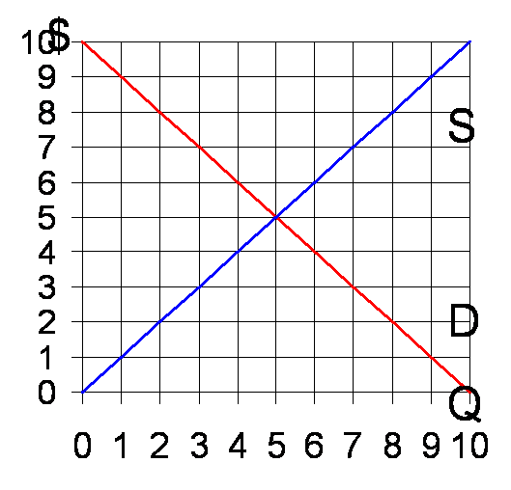At ceiling price of $3:

QD =7

QS = 3

QCeiling = minimum of QD and QS

= 3

Producer Surplus easy to calculate

(All sellers who want to sell are able to sell). So we use normal rule of calculating area under the PS line (the price producers get) and above the supply curve.

Easy to calculate ∆PS



Change in PS from $3 ceiling

What is CS?

It depends

There are 7 people who want a widget (D1, D2, D3, D4, D5, D6, D7), but only 3 are for sale. CS depends on who gets the widgets because they differ in willingness to pay.

**CS under the price ceiling is**

**NOT THIS!**



3 widgets consumed, not 7!

One Extreme: Case 1

Perfectly Efficient Rationing

Highest value consumers get the widgets (rationing goes their way)



CS = _______

For this extreme case, how does consumer surplus compare with its level in the free market?

Lesson:

What about overall total surplus?

Opposite Extreme: Case 2

Perfectly Inefficient Rationing

Lowest Value Consumers that want widget get it. **CS is much lower!**



CS = _______

Something in between?

Uniform Rationing (likelihood of getting good unrelated to willingness to pay)

What if D2, D4, and D6 get widget?



Case 3: Uniform Rationing

CS = ______

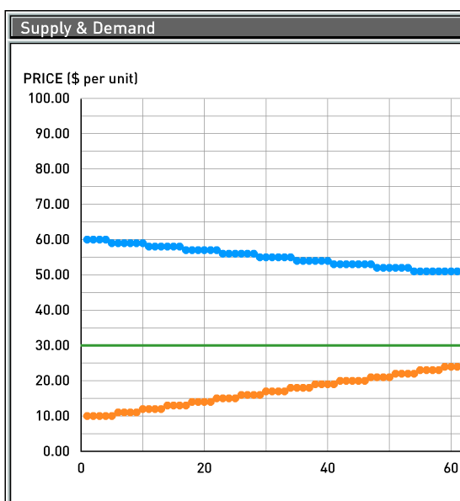Review price ceiling in Aplia experiment from last week.

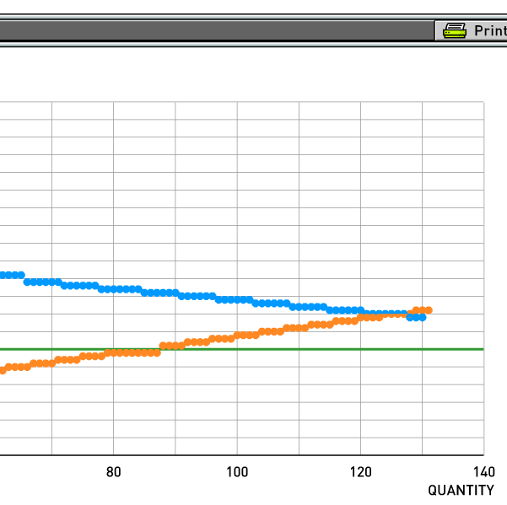

**Rationing in ApliaLand**

What case is most relevant?

Next. If you were a buyer, what was the best strategy?