Lecture 5(ii) Announcements
- Practice midterms at Canvas
- Question and Answer Sessions
- Wed Oct 3: 4-5:30: Anderson 310
- Wed Oct 3, 7:30-9: Anderson 210
- Thur Oct 4 3:30-5 : Anderson 210
- Large Lectures (those meeting in Willey 175) cancelled on Friday.
- Next Mon (Oct 8), go to evening midterm, 7-8pm instead of lecture.
- Bring #2 pencils and University ID
- Don’t Bring: Calculators and Scratch Paper.
- My Office hrs.
  - Today 1:30-3:25
  - Tomorrow 1:30-2:30.

Lecture | Midterm Location
1 MWF 09:05-09:55am (Holmes)
Discussion Sections 2, 3, 4, 5, 16 | Anderson 310
Discussion Sections 6, 8, 9, 11, 15 | Anderson 210
Discussion Sections 12, 13, 18, 19 | Blegen 5
Discussion Sections 20 | Anderson 370
Discussion Sections 21 | Anderson 270
22 MWF 10:10-11:00am (Holmes) | Wiley 175
44 (Tosun) | Anderson 370
54 (Raya Munte) | Anderson 330
62 (Choi) | Anderson 250
66 (Hua) | Anderson 350
72 (Rabello De Castro) | Anderson 270
77 (Roos Guthmann) | Blegen 10
78 (Serio) | Blegen 10

Lecture
1. Cap and Trade of Milk
2. Price Ceilings with Resale
3. Handy summary of policies
4. A Few Comments about Midterm

1. Cap and Trade

What is it?
- Gov’t limits production by distributing quota.
  - One quota needed for each unit produced.
  - Amount of quota out there is the cap
- Firms can trade quota

Examples:

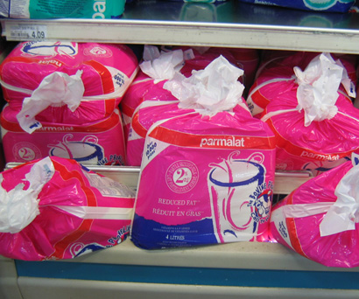
Cap and Trade
for Milk
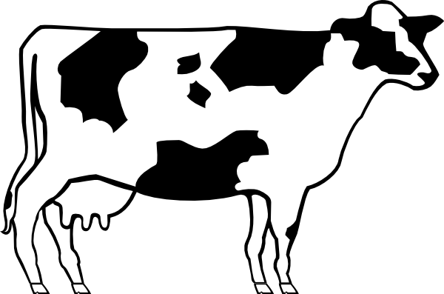

Since 1970s
Cap and Trade has
been used in Canada for dairy.

One quota unit = right to produce
one kilogram milk butterfat a day.
(Amount what one cow produces)

Trade in quota exchange.
Quota markets in each province are separate.

Current quota prices (in $CAN as of Sept 2018)

Alberta: $39,500
British Columbia: $38,500
Ontario: $24,000

Quota for herd of 200 cows in Alberta = $7.9 million!

In the news: The system won’t work if you let in imports. Dairy in Canada, a big story now. Come back to this.

Cap and Trade for CO² or SO²
Motivation:

What is motivation for cap and trade of milk?
- Too much milk on cereal?
- Too much extra cheese on pizza?

Actual motivation?

Cap and Trade in Econland
Set up program so farmers get $7 for their widget milk....
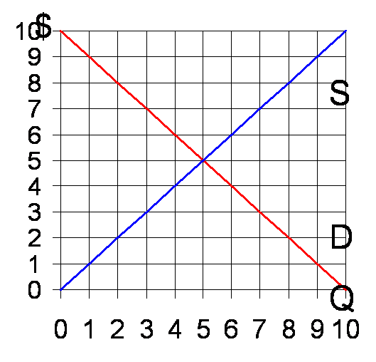

There is excess supply when the price is 7, so something will have to be done about it.

To get widget price to $7, the amount of quota (cap on total production)
will have to be _____________

Let’s work out what happens with quota at this level

Step 1: Compare total quota to free market quantity. If quota is more than free market, irrelevant and price of quota = 0. If quota quantity less, then market quantity is quota.
Here Quota=3 < 5 (unregulated Q)

Step 2: Get widget price from demand curve at quota.

Here P = $7.

Step 3: Set price of quota so marginal producer breaks even taking into account the opportunity cost of quota.

Total cost = $production cost
+ $cost of quota

Marginal production cost at Q = 3 is $3. (see this on S curve)

If total cost equals $7, marginal producer just breaks even.
Thus

Price of quota = $7 − $3 = $4.

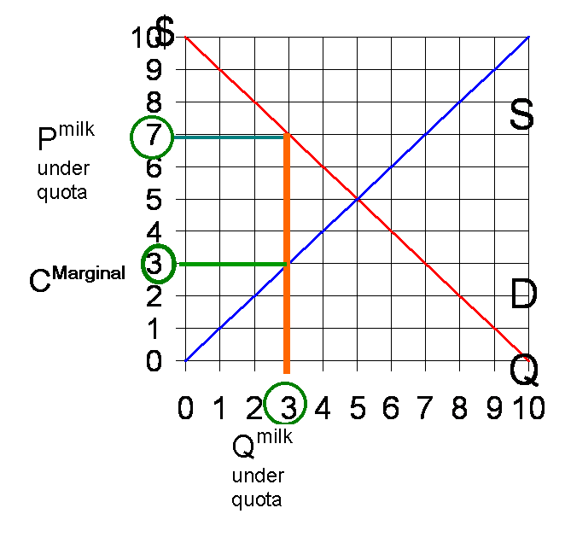
Check that this works. (That both markets are in equilibrium)

Think of opportunity cost!

Let farmers maintain two books

Milk business (where deduct opportunity cost of using quota)

Quota business (where make money on quota if lucky enough to have inherited some)

When price of quota equals $4, the marginal producer just breaks even on milk business.
Effects of Quota Policy

Variable | Free Market | Quota of 3 | Change
P^{Milk} | 5
Q | 5
P^{Quota} | 0
CS | 12.5
PS^{Milk} | 12.5
PS^{Quota} | 0
PS^{Combined} | 12.5
TS | 25

We determined

Price of Quota = P^{milk} − C^{Marginal}

= $7 - $3 = $4.

Important point: Just calculated the value of quota for one day’s use.

In actually, get to use it day after day.

Value for one year:
365 × $4 = $1,460

Value for ten years:
(if interest rates are zero)
10 × $1,460 = $14,600
Going back to the Canadian Dairy market

- Interest rates are not zero, so we need to discount future benefits ($1 ten years from now worth less than $1 today)

- Also take into account quota still will have value beyond 10 years (assuming government does not change the rules). Potentially may go on indefinitely, making quota ownership like land ownership.

Now connect to the news.

Milk $6 a gallon in Canada
$3 a gallon here.

Where would an American dairy farmer want to sell milk?

With free trade in milk, supply management would not work.
So ban all imports is the first thing Canada would do.

But with trade negotiations, let some imports in, but up to a quota (and with a small tariff 7.5 percent).

Simplest thing would be to ban all imports above the quota. Instead they set a ridiculously large tariff 270% that no one pays.

Now to trade policy. Trump administration renegotiating NAFTA
Trump points to 270% tariff as Canadians are terrible.

For public relations that Canadian would do better to just have a quota, and negotiate how big the quota can be. In the Trans Pacific Partnership (TPP) which Trump pulled us out of, Canada had agreed to increase import quotas.

The U.S. uses import quotas for sugar and through them keeps sugar prices twice as high as in Canada.

Canada uses import quotas for milk, which are need to keep milk prices twice as high as in the U.S.

As a consumer, I would like to buy milk in the U.S. and sugar in Canada!

Price Controls: Big picture

- Start with first welfare theorem. With no externalities and no monopoly, the free-market allocation is Pareto efficient
- Price system acts as an invisible hand in such a way that
  - Consumers willing to pay market price all buy (efficient allocation of consumption)
  - Producers with cost less than the market price produce (efficient allocation of production)
  - Value of last unit in equals its cost (efficient quantity)
Taxes and subsidies
- distort quantity.
- But price system is still put to work in allocating consumption and production.

Price controls (a ceiling that price can’t go above, a floor that price can’t go below)
- distort quantity AND
- distort allocation on the side of the market facing rationing
  - buyer side with price ceiling
  - seller side with price floor.
Price Ceilings with Resales

What if we bring the market back, and let resales be possible?

Law in EconLand: S people cannot sell widget for more than $3.
D people allowed to resell at any price.

What happens?

Step 1: Take ceiling of $3 and figure out how much the S people are willing to sell. This is Q = 3.

Step 2. Draw a vertical line at Q=3 above the price P=3. This is the supply of goods in the resale market

Step 3. Demand in the resale market is the original demand curve. Even if a particular D person is able to initially buy a widget from an S person for $3, the D person needs to consider whether it is worth holding onto it or reselling. The opportunity cost of consuming a widget is the price the widget could sell for in the resale market.

Step 4: Demand and Supply in the resale market yields an equilibrium resale price
P = $7.
At an opportunity cost of $7, 3 units are demanded in the resale market and this equals supply.

Consumer surplus in the resale market is consumer surplus at pD=$7.

Producer surplus obtained by the S people in the original market is producer surplus at
pS = $3.

The green box is “scalping profit,” the money made when someone buys a widget for $3 and resells it for $7.

Note that when resale is possible, market forces will ensure that the widgets end up going to those with the highest willingness to pay. (That is, D1, D2, and D3 well end up outbidding the others and each will consume a widget). It may be the D10 gets lucky and buys all 3 widgets at the initial price of $3 and sells them to D1, D2, and D3 at $7. In this case, D10 gets the green box of scalping profit.

What would happen if D1, D2, and D3 each were lucky enough to buy widgets at the initial price of $3? We can think of them as first selling their widgets in the resale market at $7 and then buying them back at $7. In this case, the green box goes to D1,D2, and D3.

Note that the surplus they get, red triangle plus green box, is exactly the same as the surplus with efficient rationing (where D1, D2, and D3 get widgets) that we calculated earlier in the class.
Bottom line:
If a price ceiling of $3 is set and resales are illegal, then in general we expect two sources of inefficiency:
- Output is too low (violates condition 3)
- Highest valuation consumers don’t always get the good first (violates condition 1)

If resales are legal, that won’t do anything about quantity being too low. (The S people will still sell only 3 units at a price of $3). However, allowing the resale market means the free-market is put to work determining how the 3 available units are allocated. The workings of the market will ensure they end up going to the people with the highest willingness to pay.

2. Handy summary of the effects of policies

Q
$
D
S
Q_{low}
Q_{efficient}

For all policies on next page:

Goes to consumers

Goes to producers

Is loss in total surplus
from output being too low
(Q_{low} instead of Q_{efficient)}
Where
goes depends upon policy
Policy | Where green box goes
Tax | Government
Quota | Quota Owners
Price Ceiling  efficient ration  (unlikely) | Consumers
Price Ceiling (more likely) | Partly destroyed by inefficient allocation
Price Floor efficient ration  (unlikely) | Producers
Price Floor (more likely) | Partly destroyed by inefficient allocation

Where does subsidy fit the table?

It doesn’t fit in.

Subsidies make quantity too high.

Midterm
Bring:
#2 Pencils, University I.D.

Don’t Bring:
Calculator, scratch paper

Syllabus on Academic Dishonesty
“The test-taking period begins when a student is handed the question sheet and ends after the student’s answer sheet has been collected. During the test-taking period, a student may not speak with any other student, nor use any communication device or notes. Any violation of this rule, regardless of the subject matter of the communication, is considered a form of academic dishonesty, and it will not be tolerated in this class.”
Coverage: Everything we have done, including this lecture.

Good if you have worked through both the book and the lecture notes.

But if have to pick one or the other, pick the lecture notes.

Readings
1) Electric Power
2) Long and Short Run Elasticity
3) Cap and Trade for Milk

