Lecture 6(ii)

Announcements

* Global Issue 1 Platform Debate: Carbon Policy to be held in recitations next week.
  + Recitations this week explain how this will work.
  + You can start thinking about policies by looking at visiting the page posted at week 7 of Canvas, “Web Links related to Global Issue 1”

Lecture

Will cover: International Application

Reading 4: Cap and Trade and Carbon Emissions

1 Government Policy with Externalities:

Taxes (Pigouvian Tax)

Command and Control

Tradable Allowances (also known as “cap and trade”)

2. Climate Change Economic Policy

Gas Tax? Cap and Trade?

Subsidize innovation?

Other ideas? (Let’s hear them next week in the platform debate.).Recall tax analysis in Econland when we didn’t say anything about externalities

|  |  |  |  |
| --- | --- | --- | --- |
|  | Free Market | $4 tax | change |
| Q | 5 | 3 | -2 |
| PD | 5 | 7 | +2 |
| PS | 5 | 3 | -2 |
| CS | 12.5 | 4.5 | -8 |
| PS | 12.5 | 4.5 | -8 |
| GS | 0 | 12 | +12 |
| CS+PS+GS | 25 | 21 | -4 |



**PD**

**Qtax**

**Qfreemarket**

**PS**

**Tax Revenue**

ΔCS+ ΔPS+ ΔGS

Now recognize the existence of a negative externality:

Production of 1 widget imposes an external marginal cost of $4 on others

None of the above changes.

The cost is **external** to the decision makers so doesn’t affect what the do and what they get.

But the socially optimally quantity changes!

Is now lower than the freemarket level.

First Welfare Theorem doesn’t hold



**PS**

**PD**

**Qtax**

**Qfreemarket**

**SMC**

The numbers without taking the externality into account:

|  |  |  |  |
| --- | --- | --- | --- |
|  | Free Market | $4 tax |  |
| Q | 5 | 3 | -3 |
| PD | 5 | 7 | +2 |
| PS | 5 | 3 | -2 |
| CS | 12.5 | 4.5 | -8 |
| PS | 12.5 | 4.5 | -8 |
| GS | 0 | 12 | +12 |
| CS+PS+GS | 25 | 21 | -4 |

Let’s think of “mother nature” as another party involved here who is suffering the damage from the externality. Let’s add another row to take her into account.

|  |  |  |  |
| --- | --- | --- | --- |
|  | Free Market | $4 tax | Change |
| Q | 5 | 3 | -3 |
| PD | 5 | 7 | +2 |
| PS | 5 | 3 | -2 |
| CS | 12.5 | 4.5 | -8 |
| PS | 12.5 | 4.5 | -8 |
| GS | 0 | 12 | +12 |
| CS+PS+GS | 25 | 21 | -4 |
| Externality | -20 | -12 | +8 |
| Total Surplus  Including Externality | 5 | 9 | +4 |

Picture: From above



**PD**

**Qtax**

**Qfreemarket**

**PS**

**Tax Revenue**

ΔCS+ ΔPS+ ΔGS

This picture leaves out the externality. Let’s put it in.

Effect of $4 taxHere is how to think about the previous slide. On account of the tax, Q goes down by 2 units, so Mother Nature is ahead by $8=$4*2. (This is the change in the externality, the black parallelogram. We need to subtract out the yellow triangle from the previous pages, which is the change in CS+PS+GS. After this deduction, we are left with the aqua colored triangle as the impact of the tax on total surplus. On account of the externality, a $4 tax actually raises surplus.



**PS**

**PD**

**Qtax**

**Qfreemarket**

**SMC**

ΔTS including

Externality

ΔExternality (positive)

The idea of this kind of tax is due to Arthur PigouArthur Pigou, 1877-1959

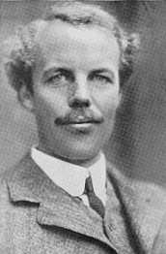

With $4 tax, consumer is paying true social cost of another widget

Pigouvian Tax

Internalize the externality

With a $4 tax, any firm making a decision to produce a widget pays the true social cost of the widget.

Note that if instead we set a tax of $10, this would be more than the externality of $4. If the tax were $10, the entire market will be shut down. Total surplus would be 0, which is less than it would be with the free market (where it equals 5).

Let's now consider other ways to address the externality besides a tax.

An alternative:

Command and Control

Want to get from market quantity of 5 to 3? How about requiring each supplier (S1-S5) to cut back and make only .6 widget instead of 1 widget each.

So total widget quantity is 3 = .6×5

Real world equivalent:

* Fuel Efficiency standards on cars. Obama made them more stringent, Trump rolling them back
* Mandatory scrubbers on power plants
* Mandatory cutbacks at each plant

Problem with this policy in Econland

We don’t have efficient production. S5 is producing while S1 still is not at capacity. Should shift production from S4 and S5 to S1,S2,S3 to be efficient.

Problem with Fuel Efficiency Standards (as compared to market solutions)

1. Does nothing about existing cars.

2. Different standards for different kinds of cars. No incentive to switch from SUV to small car.

Tax is more efficient.

But one problem with the tax:

Politically not popular!

How get same impact on efficiency as tax?

Solution: A market based method

Cap and Trade

Same as tax, except the green box ($12) goes to the owners of the allowances.

For example: one possibility:

Suppose S1-S5 each initially allocated .6 allowances. (Are each capped at .6 in emissions. So total cap is 3 = 5*.6

Cap and Trade has been used in the U.S. to reduce sulphur dioxide emissions from power plants. (SO2 causes “acid rain.”)

What happens when S1, S2, S3, S4, S5 each get .6 allowances each and they are tradable? The market will work exactly like the tradable quota in the dairy industry from Reading 3. (Allowances and quota are equivalent concepts.)

The equilibrium price of one allowance unit will equal $4. When the opportunity cost equals $4, the last producer in (S3) just breaks even. To see that S4 and S5 will want to sell out, observe that S4 gets $4*.6 = $2.40 from selling out her .6 allowance units. If instead she stays in business, she gets .6*($7-$4)=.6*$3 = $1.80. (With pD = $7 and a cost of $4, she makes $7-$4 per unit she sells. She sells .6 units, so she makes $1.80. She is better off selling off her allowance for $2.40 than using it herself.

2. Climate Change and Economic Policy

Lot of controversy about climate.

Here is one viewpoint:

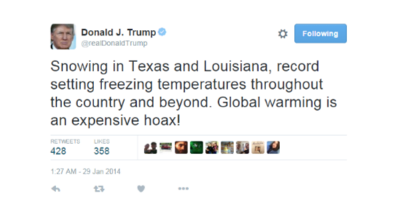

* Let’s look at facts. Let’s look at NASA site.

<https://climate.nasa.gov/vital-signs/global-temperature/>

Here is what is happening to temperature:

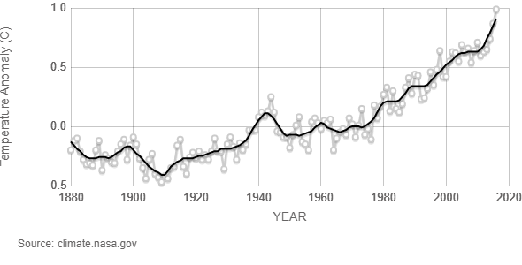

* Consensus view of scientists is that global carbon emissions a major contributor underlying this change.

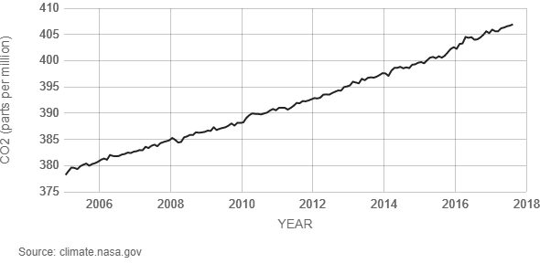

Key point to recognize: Global Issue.

Would be a lot easier to solve if each country’s policies affected their own climate.

Global nature requires a global response, and that is why the United Nations is involved.

(We don’t need the UN to enact policies that make husbands put down toilet seats for their wives, as this is an externality that operates at the household level.)

Point of Paris Agreement:

Get all countries on board.

Background:

Kyoto Protocol signed in 1997 and into effect in 2005

The European Union pushed it and signed it, and imposed reductions upon themselves.

US didn’t go along with it.

Japan later backed out.

US argument: It won’t do any good for the U.S. and Europe to cut back if it is completely offset by growth in emissions by China and India.

Developing country argument: We are poor and want to live better. Why should we cut back when you are driving around in SUVs?

Back in 1997 China’s emissions were small and the US was the biggest emitter.

Fast forward to today

* China is the largest emitter in the world, twice as high as U.S. (But there are four times as many people as US, so per capita is half the US).
* China has surpassed the European Union on a per capita basis

Obviously, any kind of agreement would have to include China and the US and in 2015 things were happening on both margins.

In China, President Xi Jinping has announced a cap and trade system starting 2015

In the U.S., President Obama began taking unilateral executive action, through the EPA, regulating carbon emissions of coal plants as a pollutant. (Clean Power Plan)

Paris Agreement:

US + China + India

and everyone else except for

Syria and Nicaragua (who did sign).

June 1, 2017 President Trump pulled U.S. out.

More recently the EPA has dismantled Obama’s Clean Power Plan

Issue has not just been about carbon, but mercury, SO2. More regulations on this stuff makes coal less economic, especially with the current low natural gas prices.

Trump administration is rolling back these regulations.

Previously, when you invested in an old plant to make it more efficient, you also needed to upgrade pollution mitigation. Now plants can upgrade without doing this. This policy will likely extend the life of old plants, delaying substitution into alternative plants with lower carbon footprints.