Lecture 7(i)

Announcements

1) Still processing exam score. Expect to have them finished soon.

2) For large lectures, there is no class Wed of Thanksgiving week.

3) No recitations Thanksgiving week

4) Platform debates in discussion sections this week

Participation counts towards your homework grade

Lecture

1. Further Discussion of Global Issue 1: Carbon Policy

2. New Issue: International Trade

3. Impacts of Tariffs and Quotas

Lesson From last week:

Key point to recognize: Global Issue.

Would be a lot easier to solve if each country’s policies affected their own climate.

Global nature requires a global response, and that is why the United Nations is involved.

(We don’t need the UN to enact policies that make husbands put down toilet seats for their wives, as this is an externality that operates at the household level.)

Point of Paris Agreement:

Get all countries on board.

Background:

Kyoto Protocol signed in 1997 and into effect in 2005

The European Union pushed it and signed it, and imposed reductions upon themselves.

US didn’t go along with it.

Japan later backed out.

US argument: It won’t do any good for the U.S. and Europe to cut back if it is completely offset by growth in emissions by China and India.

Developing country argument: We are poor and want to live better. Why should we cut back when you are driving around in SUVs?

Back in 1997 China’s emissions were small and the US was the biggest emitter.

Fast forward to today

* China is the largest emitter in the world, twice as high as U.S. (But there are four times as many people as US, so per capita is half the US).
* China has surpassed the European Union on a per capita basis

Obviously, any kind of agreement would have to include China and the US and in 2015 things were happening on both margins.

In China, President Xi Jinping has announced a cap and trade system starting 2015

In the U.S., President Obama began taking unilateral executive action, through the EPA, regulating carbon emissions of coal plants as a pollutant. (Clean Power Plan)

Paris Agreement:

US + China + India

and everyone else except for

Syria and Nicaragua (who did sign).

June 1, 2017 President Trump pulled U.S. out.

More recently the EPA has dismantled Obama’s Clean Power Plan

Issue has not just been about carbon, but mercury, SO2. More regulations on this stuff makes coal less economic, especially with the current low natural gas prices.

Trump administration is rolling back these regulations.

Previously, when you invested in an old plant to make it more efficient, you also needed to upgrade pollution mitigation. Now plants can upgrade without doing this. This policy will likely extend the life of old plants, delaying substitution into alternative plants with lower carbon footprints.

Carbon Emissions

from Energy Consumption

(Billions of tons)

|  |  |  |  |  |
| --- | --- | --- | --- | --- |
| Country | Year | | | |
| 1990 | 2000 | 2007 | 2015 |
| US | 5.0 | 5.9 | 5.9 | 5.2 |
| Europe | 4.4 | 4.1 | 3.9 | 3.5 |
| Japan | 1.2 | 1.3 | 1.3 | 1.3 |
|  |  |  |  |  |
| China | 2.5 | 3.7 | 7.6 | 10.7 |
| India | 0.7 | 1.1 | 1.3 | 2.5 |
| Rest of World | 8.9 | 9.7 | 12.2 | 13.0 |
|  |  |  |  |  |
| World | 22.7 | 25.8 | 32.2 | 36.2 |

Source: European Commision, Joint Research Center,”Trends in Global CO2 Emissions.”

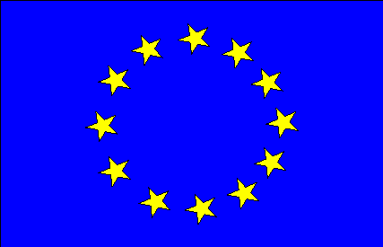Carbon Policy in European Union

1. EU Emissions Trading System

(<https://www.youtube.com/watch?feature=player_embedded&v=yfNgsKrPKsg>

Issue: Last year supply of allowances was large relative to demand and price was €5 a ton.)

This year, fewer allowances available. Guess what happened to price?

€20 a ton. Let’s see the economics:

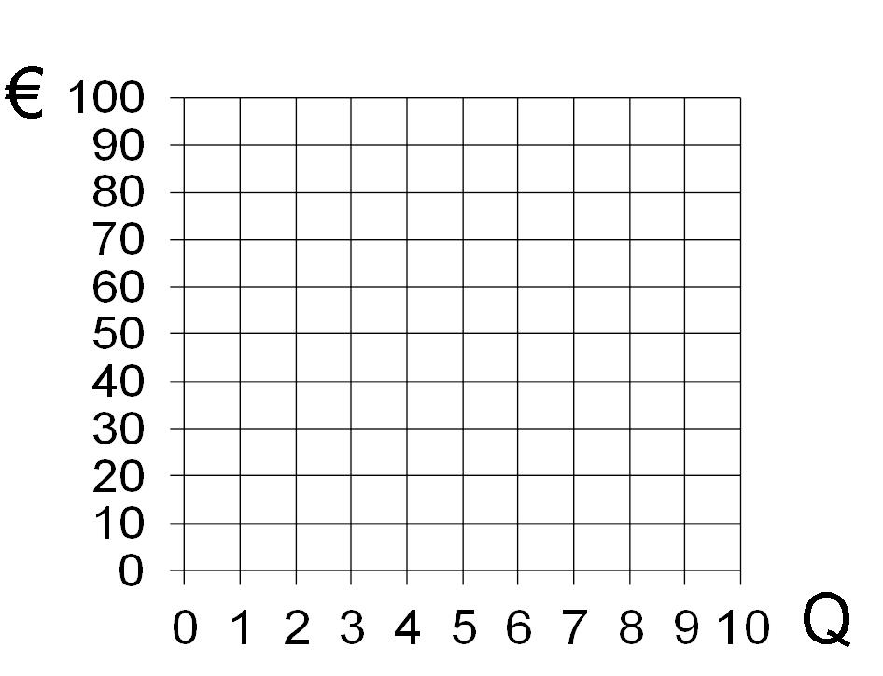With 6 allowances, market price will be _____ based on year 2000 supply and demand. What will price actually be in 2017 for allowances? ______.

D2017

D2000

S2000=S2017

But if EU cuts allowances to 3?______

2. Carbon taxes

(existing high gas taxes)

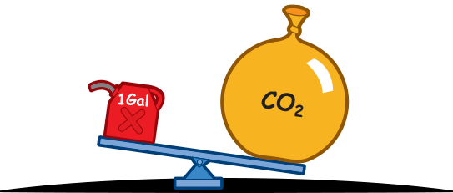

20 pounds

(1 gallon gas→ 20 lbs CO2)

A number of studies suggest (as a ballpark figure)

**$20 per ton of CO2**

an appropriate Pigouvian tax.

That’s 20 cents a gallon. Germany gas tax is already $3 a gallon!

3. Subsidizing clean technology



Germany’s push for clean energy

**energiewende**

or “energy transition” (see New York time article and video)

<http://www.nytimes.com/2014/09/14/science/earth/sun-and-wind-alter-german-landscape-leaving-utilities-behind.html?_r=0>

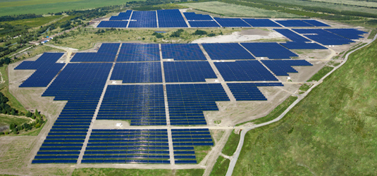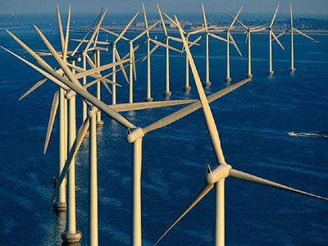Getting 30% of electric power from “clean” energy (wind/solar), (compared to 15% in US)

Key problem with Germany’s policy:

* Wind and solar are **intermittent**.
* So need conventional sources as backup.
* But how can conventional sources be economically viable if you only run them as backup?

**Carbon in the U.S.**

Emissions down since 2007.

Key reasons why:

1. Improvements in automobile fuel economy (Partly policy of fuel-efficiency standards)

2. Continuing decline in manufacturing

3. Natural gas replacing coal because of success of fracking

(natural gas produces **twice** as much heat per carbon emitted as coal.)

Coal Mining Jobs

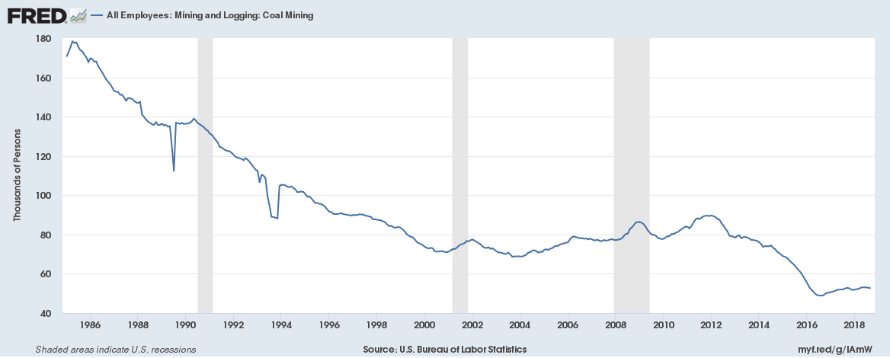

Let’s go to FRED at the

St. Louis Fed web site and plot the count of coal mining jobs

Also, let’s look at unemployment and [tax collections](https://fredblog.stlouisfed.org/2018/06/movement-of-the-federal-tax-receipt-front/)

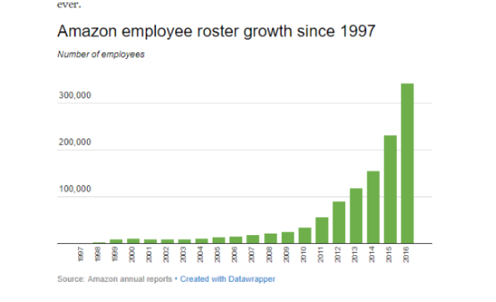By way of comparison, here is what has been going on with Amazon:

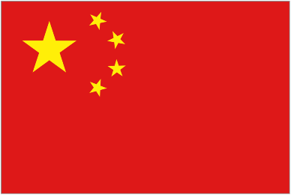**Carbon in China**

Emissions growing

Key reason why: **Economic Growth**

(See homework graph relating emissions and GDP)

Others are growing as well.

Burning coal is biggie (46 percent of all fossil fuel CO2 emissions comes from coal).

Coal tends to be dirty (particulates), so China has incentive to reduce coal even if it doesn’t take into account CO2.

Next Step:

Platform Debate on Carbon Policy in sections this week



I WANT YOU

to propose and debate a policy on this issue.

2. Global Issue 2:

International Trade

Suppose Econland opens up to trade with the rest of the world and widgets cost $1 in the world economy.

PWorld  = 1

With free trade, this will drive the price in Econland to the world price. At this price, producers want to supply 1 unit, consumers demand 9 units. The difference of 9-1=8 is made up by imports.



What happens in our Econland Demand and Supply Graph when we open up to trade in rest of world at

PWorld  = 1

Consumer Surplus

with trade

.

Qdemand

Qsupply

Pworld

Pworld

Imports

Producer Surplus

with trade

Effects of Trade when

PWorld  = 1

Table

|  |  |  |  |
| --- | --- | --- | --- |
|  | Ban Imports | Free  Trade | Change |
| P | 5 |  |  |
| Qprod | 5 |  |  |
| Qcon | 5 |  |  |
| Imports | 0 |  |  |
| CS | 12.5 |  |  |
| PS | 12.5 |  |  |
| Gov S | 0 |  |  |
| TS (Econland) | 25 |  |  |

Alternative Scenario:

PWorld  = 7

Illustrate PS and CS with free trade



Effects of Trade when

PWorld  = 7

Table

|  |  |  |  |
| --- | --- | --- | --- |
|  | Ban Exports | Free  Trade | Change |
| P | 5 |  |  |
| Qprod | 5 |  |  |
| Qcon | 5 |  |  |
| Exports | 0 |  |  |
| CS | 12.5 |  |  |
| PS | 12,5 |  |  |
| Gov S | 0 |  |  |
| TS (Econland) | 25 |  |  |

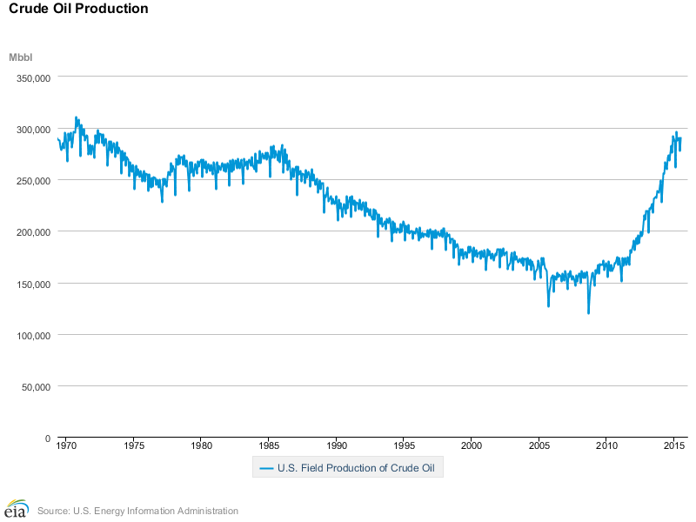Since the 1970s, we have a ban on exports of oil. Hasn’t been relevant, until very recently. Here is what monthly crude production looks like

US is still a net importer.

The issue is that there are different types of crude, and different kinds of refineries are designed for different grades of oil.

With free trade, US oil producers can get top $. With banning of exports, excess supplies of particular grades of oil can depress prices.

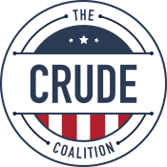Refineries think the ban on exports is great and want to keep it.

# 

Let’s now look at the effects of a $2 tariff....