Lecture 7(ii) Announcements

Debates in sections this week



Lecture

1. Carbon Emissions and Income

(Graph from Homework 5)

2. Tariffs and Import Quotas with Perfect Competition in the World Economy

3. New graph:

Production Possibility Frontier

4. A Gain from Trade:

Comparative Advantage

Graph from Homework 5

Australia U.S.

Canada

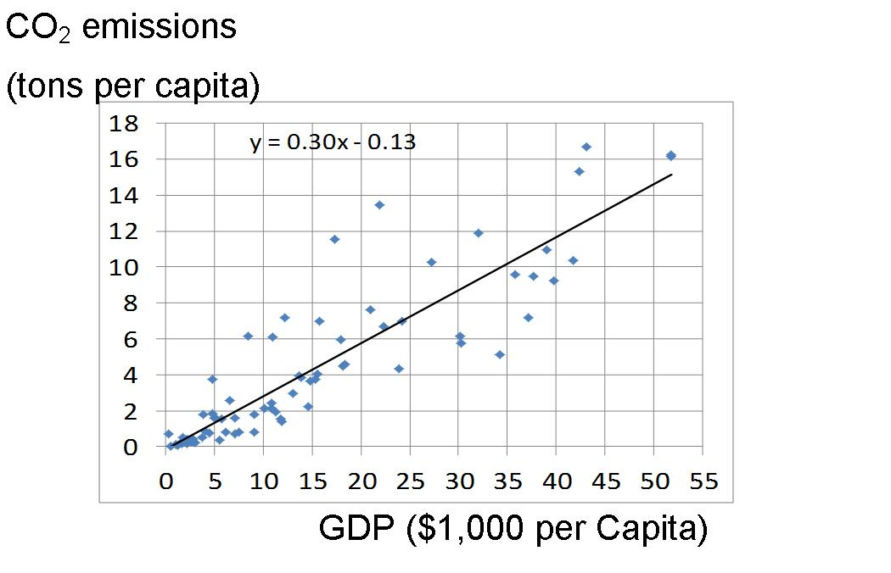

Russia

China

France

Germany

Can figure out your carbon footprint at

<http://www.epa.gov/climatechange/ghgemissions/ind-calculator.html>

Go back to free-trade in widgets, when:

PWorld  = 1

Last class: we looked at a complete ban in imports.

Today: look at tariffs and quotas

Consumer Surplus

with trade

.

Qdemand

Qsupply

Pworld

Pworld

Imports

Producer Surplus

with trade

Table

|  |  |  |  |
| --- | --- | --- | --- |
|  | Free Trade | Tariff $2 | Change |
| P | 1 |  |  |
| Qprod | 1 |  |  |
| Qcon | 9 |  |  |
| Imports | 8 |  |  |
| CS | 40.5 |  |  |
| PS | .5 |  |  |
| Gov S | 0 |  |  |
| TS (Econland) | 41 |  |  |

Now suppose there is a tariff of $2.

A tariff is a tax that is imposed on imports, but not domestic production. (For example, there is a large tariff on orange juice, 29 cents a gallon, that limits entry of Brazilian orange juice in the U.S.)

Pickup trucks: tariff is 25 percent

(On cars the tariff is only 2.5 percent)

What happens?

If PWorld  = 1 and the tariff is $2, the price in Econland will be....

Impact of $2 Tariff

When PWorld  = 1



Table

|  |  |  |  |
| --- | --- | --- | --- |
|  | Free Trade | Tariff $2 | Change |
| P | 1 | 3 | +2 |
| Qprod | 1 | 3 | +2 |
| Qcon | 9 | 7 | -2 |
| Imports | 8 | 4 | -4 |
| CS | 40.5 | 24.5 | -16 |
| PS | .5 | 4.5 | +4 |
| Gov S | 0 | 8 | +8 |
| TS (Econland) | 41 | 37 | -4 |

Suppose a quota instead of a tariff It is a limit on how many imports can come in. (Just like the quota limited milk production in Canada).

For example, there are sugar quotas limiting the import of sugar into the U.S.

(Including imports from Mexico)

Review in Nicer Pictures: Economic Impact of Tariff in Econland (Perfect Competition in the World Economy)

$

D

S

Pworld

PEcon

Imports with tariff

Imports free trade

tariff

PEcon = PWorld + tariff

Q

Effects of the Tariff

|  |  |
| --- | --- |
| ΔCS (minus) |  |
| ΔPS (plus) |  |
| ΔGS (plus)  (tariff revenue) |  |
| ΔTotal Econland Surplus (minus) |  |
| Breakdown |  |
| Qcon too small |  |
| Qprod too big |  |

Economic Impact of Quota

in Econland

Q

$

D

S

Pworld

PEcon

Quota

Imports free trade

what quota would

PEcon = PWorld + tariff

Effects of the Quota,same as tariff except green box goes abroad

|  |  |
| --- | --- |
| ΔCS (minus) |  |
| ΔPS (plus) |  |
| ΔGS | zero |
| ΔTotal Econland Surplus (minus) |  |
| Breakdown |  |
| Qcon too small |  |
| Qprod too big |  |
| transfer to  foreigners |  |

Bottom Line

Econland competing in a perfectly competitive global economy is better off overall from free trade in widgets.

Not a Pareto improvement

* Consumers (D people) are better off with free trade
* But the S people (the suppliers) are worse off.

What is the example of a real world market where this analysis capture the main issues?

Sugar

Because of quotas

* Price in US twice what it is in rest of the world
* So consume less (e.g., don’t use it to sweeten soft drinks like the rest of the world.

Suppose open up to free trade.

* Analysis shows on net U.S. ahead.
* Workers in sugar industry will lose jobs. So are worse off if get rid of quotas and do nothing else.
* But with a bigger pie, it is possible to compensate them.
  + Can help them out by paying for retraining for another job.
  + Trade Adjustment Assistance (Federal program to ease pain.) http://www.taacenters.org/

And if you want to talk about jobs?

What about the jobs in industries like candy which use sugar as in input?

With free trade in candy from the North American Free Trade Agreement (NAFTA), it makes sense to shut down candy factories here, build them in Mexico or Canada where sugar is cheap, then import the candy in to the U.S. from there, tariff free. (Sugar has a different deal in NAFTA than candy).

By the way, in June 2012, the Senate considered getting rid of the program, but it was voted down. (with Minnesota’s two senators voting against. See

<http://www.startribune.com/business/158990485.html?refer=y>

Production Possibility Frontier

Shows different production combinations available to society.

Do a simple example.

Robinson Crusoe.

(Classic novel by Daniel Defoe, 1719)

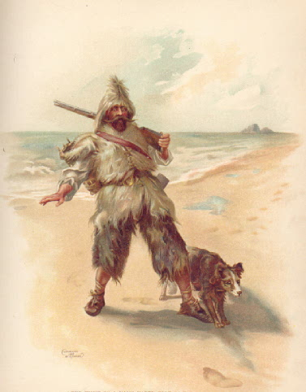

Works 8 hours a day.

In an hour, can catch 3 fish

or pick1 coconut.

If work all day on fish, catch 24.

If work all day picking coconuts, pick 8.

Production Possibilities

|  |  |  |  |
| --- | --- | --- | --- |
| Hours  Fish | Hours  Coconut | Q Fish | Q  Coconut |
| 8 | 0 | 24 | 0 |
| 4 | 4 | 12 | 4 |
| 0 | 8 | 0 | 8 |

.Production Possibility Frontier

for Robinson Crusoe



Slope: =1/3

Opportunity Cost of one more fish (in terms of coconuts)

Can think about this for production possibilities for society as a whole.

Guns and Butter

(10,100,000 google hits)

(Stadiums and K12 Education, etc, etc.)

Back to Robinson Crusoe.

Suppose autarky (no trade, on his own).

We will talk about choice next week.

But let’s say he decides to work half on each.

Production point and consumption point

produce, consume 12 fish

produce, consume 4 coconuts

3. Comparative Advantage and International Trade

Suppose another person named Friday lives on a neighboring island

Friday works only 2 hours a day.

In one hour, can collect 12 coconuts or 4 fish.

Remember: Crusoe can catch 3 fish or pick one coconut in an hour.

So Friday has an absolute advantage at both jobs compared to Robinson Crusoe in terms of productivity per hour.

Friday’s PPF



Slope = 3. Opportunity cost of fish in terms of coconuts

Opportunity cost of fish:

for Robinson: 1/3 coconuts

for Friday: 3

Robinson has a lower opportunity cost.

Robinson has a **comparative advantage** in fish.

Friday has a **comparative advantage** in coconuts.

Suppose then can go to the market and trade. Suppose market price is one coconut for one fish. What do these guys do? Specialize according to comparative advantage.

Example how both can be better off

Robinson Produces

____ fish ____ coconuts

Friday Produces

____ fish ____ coconuts

Robinson gives Friday _________

Friday gives Robinson __________

Robinson consumes

:____fish ____ coconuts

Friday consumes

:____fish ____ coconuts

Pareto improvement compared to autarky!

If have time, let’s look at a famous picture.