Lecture 7(iii)

Announcements

None

Lecture

1 Review Trade Based on comparative advantage. (Robinson/Friday Trade)

2. Trade based on increasing returns.

(Robinson 1/Robinsin 2 Trade)

3. The iPhone and the international division of labor.

4. Free Trade Area in North America

NAFTA before, now probably USMCA. Contrast with EU

Now turn to our new graph when can see quantities of two good

Remember Robinson Crusoe from last class:

Has 8 hours a day.

Can produce 3 fish in an hour

or 1 coconut.

Production Possibility Frontier

for Robinson Crusoe



Slope: =1/3

Opportunity Cost of one more fish (in terms of coconuts)

Suppose autarky (no trade, on his own).

We will talk about choice next week.

But let’s say he decides to work half on each.

Production point and consumption point

produce, consume 12 fish

produce, consume 4 coconuts

Suppose another person named Friday lives on a neighboring island

Friday works only 2 hours a day.

In one hour, can collect 12 coconuts or 4 fish.

Remember: Crusoe can catch 3 fish or pick one coconut in an hour.

So Friday has an absolute advantage at both jobs compared to Robinson Crusoe in terms of productivity per hour.

Friday’s PPF



Slope = 3. Opportunity cost of fish in terms of coconuts

Opportunity cost of fish:

for Robinson: 1/3 coconuts

for Friday: 3

Robinson has a lower opportunity cost.

Robinson has a **comparative advantage** in fish.

Friday has a **comparative advantage** in coconuts.

Suppose can go to the market and trade. Suppose market price is one coconut for one fish. What do these guys do? Specialize according to comparative advantage.

Example how both can be better off

Robinson Produces

____ fish ____ coconuts

Friday Produces

____ fish ____ coconuts

Robinson gives Friday _________

Friday gives Robinson __________

Robinson consumes

:____fish ____ coconuts

Friday consumes

:____fish ____ coconuts

Pareto improvement compared to autarky!

Let’s see the a famous picture

Comparative Advantage

Robinson PPF



Trade Produce

Trade Consume

Autarky

Op. Cost 1 Fish = 1/3 Coconuts

|  |  |  |
| --- | --- | --- |
|  | Produce | Consume |
| Autarky | 12 F, 4 C | 12F, 4 C |
| Trade | 24F, 0 C | 12F, 12 C |

as a Basis for Trade

Friday PPF



Trade Consume

Trade Produce

Autarky

Op. Cost 1 Fish = 3 Coconuts

|  |  |  |
| --- | --- | --- |
|  | Produce | Consume |
| Autarky | 4 F, 12C | 4 F, 12 C |
| Trade | 0 F, 24 C | 12F, 12C |

Robinson/Friday Trade: Trade Based on Comparative Advantage

David Ricardo: 1772-1823

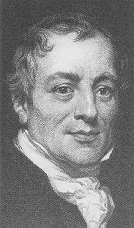

Low skill country: specialize in labor intensive,assemble sneakers

High skill, high capital country: do

design, marketing, engineering

Ricardo challenged the ideas of mercantilism (16th- 18th centuries) which were:

* Discourage imports (high tariffs), especially of manufactured goods. (importing raw materials OK)
* Encourage exports (export subsidies), (exporting raw materials not OK, make something out of them first.)
* Hoard gold.

Ricardo argued instead that imports can benefit a country, by allowing it to specialize according to its comparative advantage.

(By the way, China has found the mercantilist playbook!)

Comparative Advantage Trade

Actual Economy

Warm Climate Temperate

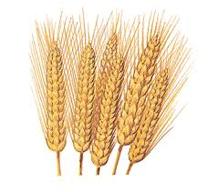 Climate

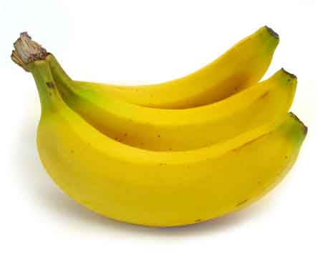

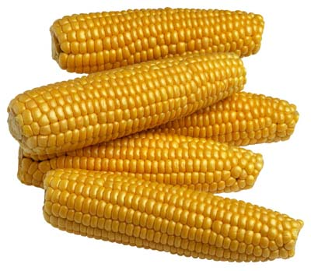

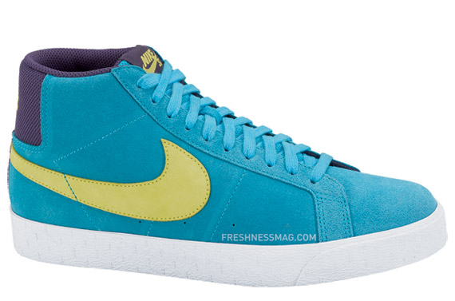Low Skill High Skill

 2. Increasing Returns and Gains from Trade

Suppose ppf looks like:



Opportunity cost one more fish falls as fish production increases

(One reason: learning by doing)

Can specialize and make:

24 fish, 0 coconuts

or

0 fish 24 coconuts

Or try to do both and make

7 fish and 7 coconuts

“Jack of all trades but master of none”

With autarky might still might do both even if not particularly good at either task without specialization.

Robinson in autarky

Perhaps produce and consume 7 coconuts and 7 fish.

Now suppose Robinson can trade with clones of himself? What do we expect to happen?

Specialization!

Robinson 1:

Produces ____ Fish ____Coconuts

Robinson Clone:

Produces ____ Fish ____Coconuts

Each consumers

____ Fish ____Coconuts

Increasing Returns

Robinson 1 PPF



Autarky

Trade Produce

Trade Consume

|  |  |  |
| --- | --- | --- |
|  | Produce | Consume |
| Autarky | 7 F, 7 C | 7F, 7 C |
| Trade | 24F, 0 C | 12F, 12 C |

as a Basis for Trade

Robinson 2 (clone) PPF



Trade Produce

Trade Consume

Autarky

|  |  |  |
| --- | --- | --- |
|  | Produce | Consume |
| Autarky | 7 F, 7C | 7 F, 7 C |
| Trade | 0 F, 24 C | 12F, 12C |

Robinson 1/Robinson 2 Trade

Trade Based on Increasing Returns

We can enjoy increasing returns and more product variety.

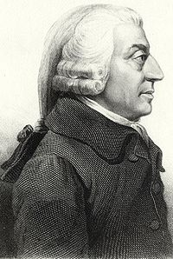Paul Krugman Adam Smith

-[](http://en.wikipedia.org/wiki/Image:Krugman_FPO.jpg)

Trade Based on Increasing Returns

Actual Economy

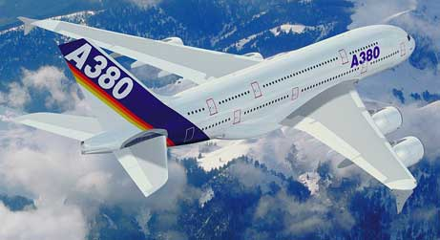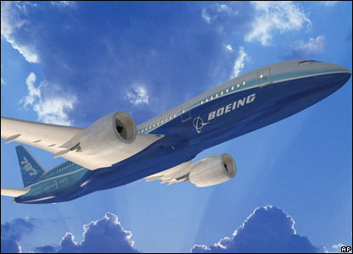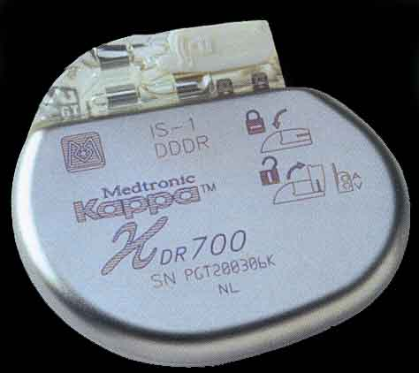Rich Country 1 Rich Country 2Trade Based on Increasing Returns

Interest in the theory driven by the empirical observation that much trade is between similar countries

U.S. and Canada,

U.S. and Europe

U.S. and Japan

all high skill countries.

With increasing returns, through trade possible for:

(1) have large production volumes of any given product

(2) consumers have a large variety

Suppose Minnesota were a country

Suppose autarky. (No trade with other states or countries)

Vehicles: Polaris

Slingshot

Movies:

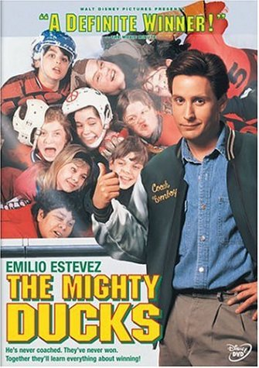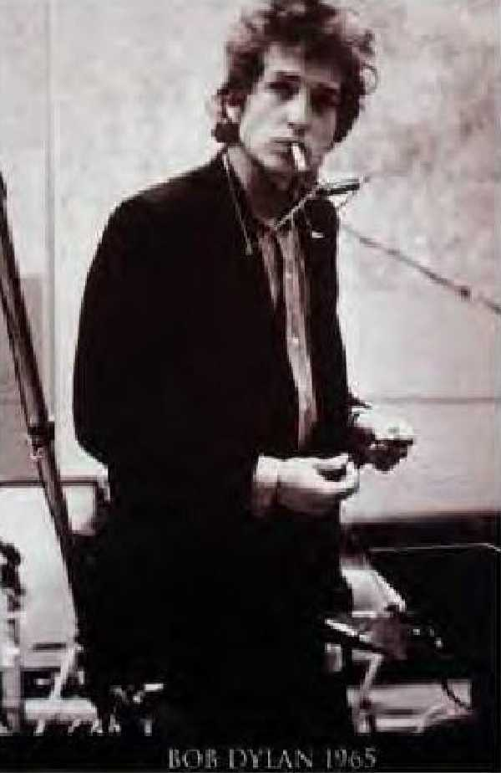Music:

[](http://sportsevents.net/concerts_buy/prince.htm)

Other Stuff



With trade, we can enjoy more variety than this

International Division of Labor

and the iPhone



iPhone 8 256GB

Price $949.00 “contract free”

(from “T-mobile” at Apple Web site)

Teardown of iPhone



<http://recode.net/2014/09/23/teardown-shows-apples-iphone-6-cost-at-least-200-to-build/>

Components (maybe $200?)

(Robinson 1/Robinson 2 Trade )

* All made in advanced economies.
  + Toshiba (Japan) making memory
  + TSMC (Taiwan) and Samsung (Korea) processor (designed by Apple)
  + Infineon (Germany) baseband
  + Broadcom (U.S) bluetooth
  + Corning (U.S) Gorilla glass
* These nations are similar (U.S. = Robinson 1, Japan=Robinson 2) in having
  + high skill labor used to develop these top-of-the-line technologies.
  + capital intensive production processes that use hardly any labor.
* Huge scale economies at work here, in R&D and development of production processes.

Assembly in China (maybe $10-$15)

(Robinson /Friday Trade)

I’ve seen an estimate of $6.50, but this strikes me as low, may not include manufacture of the very nice box, etc.

All components go to the massive Foxconn complex (300,000 workers!) for assembly. Assembly is labor intensive.

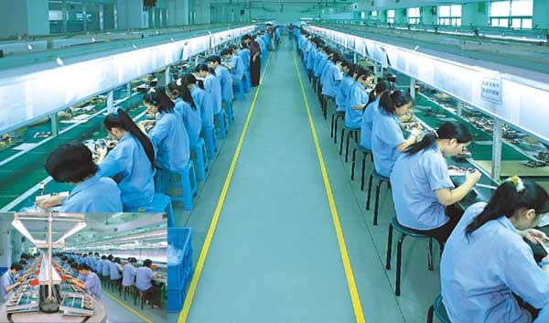

Specialization according to comparative advantage. Low skill workers earning about $170 a month.

Customer Service

(Robinson /Friday Trade)

Consumers need to call someone to get phone hooked up and resolve glitches. This is labor intensive, so goes where labor is cheap and the population can speak English.

Phillipines, where pay is ≤$500 a month.

Apple. (U.S) Estimated to keep more than half of the $650! Employs high skill workers. The $300 plus is a return on innovation, investment in apple stores, etc.

Like the Apple Store in New York

... and Shanghai

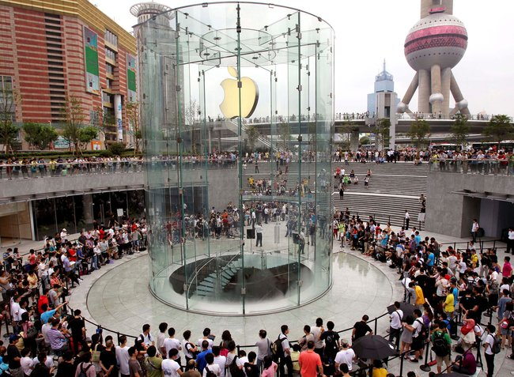

North American Free Trade Agreement might get new name

USMCA

What is it about?

US/Mexico Part: mainly Robinson/Friday trade (trade based on comparative advantage)

US Canada Part: mainly Robinson1/Robinson2 trade

(trade based on scale economies)

Other effects including political ones. (US Canada military allies. political)

NAFTA free movement of goods across 3 countries.

United States: free movement if trade of goods and people across states.

European Union: free movement of goods and people across countries.

(another plus factor is political: Made it less likely for Germany to get in wars with France and England).

Brexit: United Kingdom getting out. UK trying to get the free movement of goods part only. Let’s see what happens in March.

