Lecture 8(i)

Announcements

None

Lecture

0. Blurb about majoring in economics

1. Robinson-Friday

Robinson1/Robinson2 pictures (and connect the dots in case you missed the metaphor)

2. Further discussion of the effect of trade

3. Some Discussion of Trade between China and the U.S.

4. Free Trade Areas

5. Public Goods



Comparative Advantage

Robinson PPF

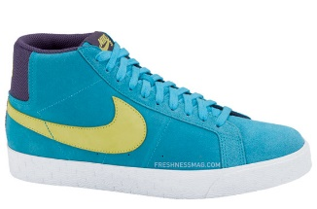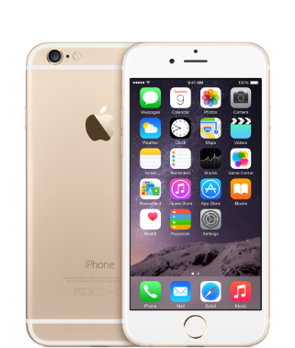

Autarky

Trade Produce

Trade Consume

Op. Cost 1 Fish = 1/3 Coconuts

|  |  |  |
| --- | --- | --- |
|  | Produce | Consume |
| Autarky | 12 F, 4 C | 12F, 4 C |
| Trade | 24F, 0 C | 12F, 12 C |

as a Basis for Trade

Friday PPF



Trade Consume

Trade Produce

Autarky

Op. Cost 1 Fish = 3 Coconuts

|  |  |  |
| --- | --- | --- |
|  | Produce | Consume |
| Autarky | 4 F, 12C | 4 F, 12 C |
| Trade | 0 F, 24 C | 12F, 12C |

Increasing Returns

Robinson 1 PPF

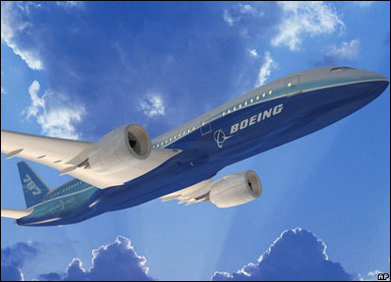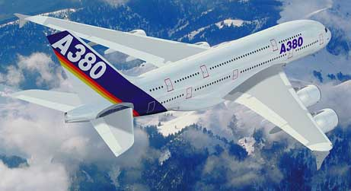

Autarky

Trade Produce

Trade Consume

|  |  |  |
| --- | --- | --- |
|  | Produce | Consume |
| Autarky | 7 F, 7 C | 7F, 7 C |
| Trade | 24F, 0 C | 12F, 12 C |

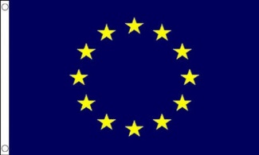as a Basis for Trade

Robinson 2 (clone) PPF



Trade Produce

Trade Consume

Autarky

|  |  |  |
| --- | --- | --- |
|  | Produce | Consume |
| Autarky | 7 F, 7C | 7 F, 7 C |
| Trade | 0 F, 24 C | 12F, 12C |

Recent economic history:

* Before 1990s,
  + US imports relatively small
  + much of it trade with advanced nations
  + or in natural resources with less developed nations
* Since 1980s, low skill workers in US have not faired well relative to high skill workers
  + Early research pointed to
    - Technological change (i.e. robots)
    - Decline in unions
    - Not trade
* Since the late 1990s
  + Imports of manufactured goods from China has exploded
  + The more recent research shows this is having impact on low wage workers
    - look at places like North Carolia which made goods like furniture now produced in China. Workers in those places are having a tough time (and if lukcy get on disability).
* The picture of Robinson trading with Friday to exploit comparative advantage highlights how Robinson wins from trade
* Picture leaves in the background that when Robinson is a country, there are different people in it with different interests:
  + consumers and high skill workers (who in the US tend to win from trade)
  + low-skill workers (who may lose)

So don’t forget about this picture from last week

.

Pworld

Pworld

Winners and losers

**∆CS > 0**

and

**∆CS +∆PS >0**

but

**∆PS < 0**

A good argument for a social safety net (e.g. expansion of Medicaid under Obamacare).

Note this looks unilateral free trade for a consumer product.

If product is input for other products, then those other industries benefit from imports (e.g. auto industry benefits from imports of steel.):

Blocking imports of labor intensive goods won’t necessarily bring the low skill jobs back, because firms may use robots instead.

Trade at world price of $1 is good overall for Econland.

What about at a world price of $0?

* Domestic producers are sure to complain that this is an “unfair” price. (For example, may only be zero because of subsidies of foreign governments.
* In this analysis, from the perspective of Econland, it doesn’t really matter why the price is zero. Overall surplus in Econland is higher when Pworld = 0

Suppose the policy goal is to maximize overall Econland surplus (and have programs to compensate workers harmed by trade)

* Appropriate policy when foreign government subsidizes widgets so price equals $0: send thank you note to foreign governments for subsidizing our free widgets. (Unilateral free trade is in Econland’s interest overall.)

If you want to make a case that unilateral free trade is not in Econland’s interest, you need to explain what’s missing in the analysis. Here are three possibilities (in addition to the points already made about the division of the pie):

(1) Argument assumes price equals the opportunity cost to product the good in Econland. Suppose instead price is greater than marginal cost because of increasing returns.

Example: Boeing Dreamliner

* $170 million dollar price tag
* Marginal cost less (eventually), let’s say $150 million. Profit margin of 20 million is a return on $5 billion R&D investment.
* If Delta Airlines is deciding between a Dreamliner or an Airbus plane, if it goes with the Dreamliner, a profit margin of $20 million stays here (in the form of going to Boeing). This is a benefit that is external to Delta in its decision making.
* Can see that the U.S. has an incentive to encourage U.S. airlines to buy Boeing planes while Europe has an incentive to encourage European airlines to buy Airbus planes. (Not in U.S. interests to adopt free trade in aircraft unilaterally)
* Still may be gains from a bilateral trade agreement between U.S. and Europe where they have free trade in aircraft and enjoy gains from variety like in Robinson 1/Robinson 2 trade.

(2) .Argument that unilateral free trade in widgets is good for Econland assumes no positive externalities from widget production in Econland.

* Suppose instead widgets are a high-tech, strategic industry with knowledge spillovers for other industries.
* There will be an incentive to promote these industries with subsidies and by restricting imports.
* Countries may want to engage in bilateral agreements to limit subsidies and import restrictions.

* Be wary of this argument, everybody seeking projection loves to claim their industry is “strategic.”

(3) National Defense. Suppose that widgets are used in warfare. Suppose that after the zero price widget imports drive out the domestic industry in Econland, there is an invasion of Econland by the army of PoliticalScienceland. PoliticalScienceland cuts off exports of widgets, and Econland has no widgets to use in self-defense.

The national defense argument for protectionist policy obviously doesn’t make sense for industries like slippers, furniture, sugar!

3. More on China/US Trade

Some industries are intensive in

low-skill labor. **China has a comparative advantage in these**.

Other industries are intensive in

high-skill labor and high technology.

**The U.S. has a comparative advantage in these.**

The homework provides some evidence that the pattern of trade is consistent with specialization according to comparative advantage. (Note: you still have to do the homework to calculate the slope of the regression line!)

Low skill industries tend to pay low wages. There is pattern in the data that China has tended to gain the most market share in those industries that paid low wages within the U.S.

Example: House slipper manufacturing wage = $7.16 in 1997. As of today, this industry has been virtually wiped out by Chinese.

House Slippers

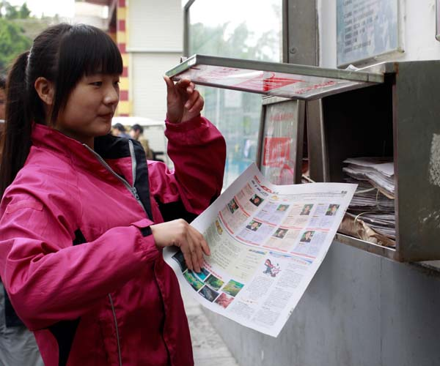

Meet a typical worker at Foxconn assembling iPhones (as described in China Daily, April 2014

<http://www.chinadaily.com.cn/business/2014-04/22/content_17448989.htm>

Working overtime at 10 hour days, earns 3,700 yuan a month ($600).

No way a factory in US can pay someone $600 a month to work 10 hour days.

Comparative Advantage Trade

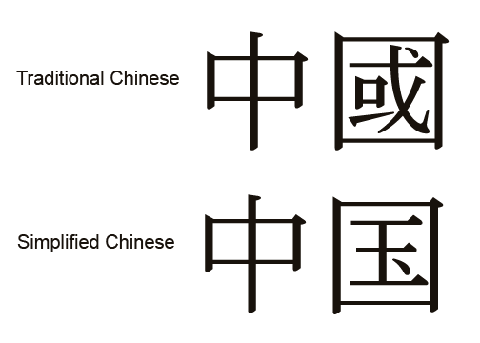China . US









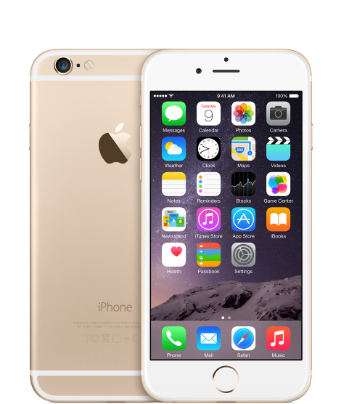https://moodle.umn.edu/theme/UofM_maroon/logo/logo.gif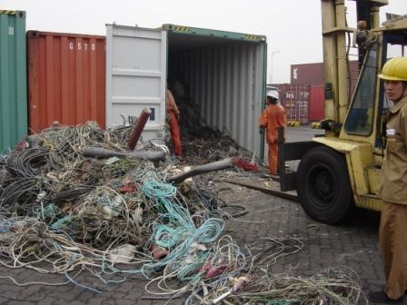

assembly

of iPhone

R&D

for

iPhone

Manufacturing jobs that involve labor-intensive, repetitive tasks in the manufacture of standardized good have been wiped out in the U.S.

* The textile and furniture industries, that had earlier located in places like North Carolina for low wages, have been decimated.

Another example: recall discussion of division of labor of iPhone

* Design: Apple headquarters in California
* Assembly: Foxconn in Shenzhen.

Important: China is moving up technology ladder

* One reason: making enormous investments in human capital

* Another reason: forced technology transfer for access to market
  + For more, see “[Quid Pro Quo](https://www.minneapolisfed.org/research/economic-policy-papers/the-costs-of-quid-pro-quo),” article by Holmes, McGrattan, Prescott
  + GM, Ford, Volkswagen forced into joint ventures to sell in China’s market
  + Tesla in news today. Opening in China without joint venture but will pay 25% tariff instead.

4. Free Trade Agreements

North American Free Trade Agreement might get new name

USMCA

What is it about?

US/Mexico Part: mainly Robinson/Friday trade (trade based on comparative advantage)

US Canada Part: mainly Robinson1/Robinson2 trade

(trade based on scale economies)

Other effects including political ones. (US Canada military allies. political)

NAFTA free movement of goods across 3 countries.

United States: free movement if trade of goods and people across states.

European Union: free movement of goods and people across countries.

(another plus factor is political: Made it less likely for Germany to get in wars with France and England).

Brexit: United Kingdom getting out. UK trying to get the free movement of goods part only. Let’s see what happens in March.



5. Public Goods

New words:

Rivalrous in consumption

I eat it, you can’t.

Excludable

People can be prevented from consuming it.

These are the two characteristics of a private good.

The widget in Econland is a private good.

Nonrivalrous in consumption

One person consuming the good doesn’t take anything away from another’s ability to consume it.

* Tornado siren. I hear it, you can still hear it.
* Watching a TV show

Nonexcludable

Can’t prevent people from consuming the good.

* Tornado siren. Can’t set it up so that only those paying for the service get to hear it. (Unless make it work through cell phones)
* TV programming? Once was not excludable (old fashioned over the air). But now can be excludable with pay-for-view, etc.

Public Good

* Nonrivalrous
* Nonexcludable

Examples:

Tornado Sirens,

Street lamp

National Defense

Research (if no patent system)

Music and Film

(if no intellectual property production)

Efficient Provision

of Public Goods

vs.

Efficient Provision of Private Goods

Private Good: rule: should make another unit of output and give it to a person if that person’s marginal willingness to pay exceeds the marginal cost.

D1: values a widget $9

S1: can produce at $1.

Make the widget!

Different story with public goods.

I never told you this, but Econland has no sun! (So dark all the time)

Proposal: Build an artificial sun, will light all of Econland.

Cost of project is $20.

What is willingness to pay?

:

|  |  |  |  |
| --- | --- | --- | --- |
| Name | would pay | Name | would pay |
| D1 | 9 | S1 | 0 |
| D2 | 8 | S2 | 0 |
| D3 | 7 | S3 | 0 |
| D4 | 6 | S4 | 0 |
| D5 | 5 | S5 | 0 |
| D6 | 4 | S6 | 0 |
| D7 | 3 | S7 | 0 |
| D8 | 2 | S8 | 0 |
| D9 | 1 | S9 | 0 |
| D10 | 0 | S10 | 0 |

If this were a private good at a cost of $20 per unit, the efficient amount would be zero.

Public good: Add the willingness to pay of each together.

If the artificial sun is build, all get to enjoy it.

Social Marginal Benefit from building the artificial sun is:

9 + 8 + 7 + 6 + 5 + 4 + 3 + 2 + 1

= $45.

Greater than $20.

So socially efficient to build the artificial sun.

In the free market, there is a:

**free rider problem**.

Beneficial on net for society as a whole, but no one willing to put up the whole amount to do it themselves.

Have a role for government.

Gov’t were to tax D1-D4 $5 each, there would be a Pareto improvement

One last point: because of technological change things can become excludable that before were not excludable, and the other way.

Suppose can build an artificial sun where you need a certain kind of sunglasses to see the light.

Entrepreneur build the artificial sun, sell sunglasses to people for $5

D1-D5 buy, get $25 in revenue. Pays for the $20 investment.

The good is now excludable.

Key point: in this case will need intellectual property protection to get the innovation.

If someone can sell bootleg sunglasses, then the entrepreneur unlikely to be able to make a go of it.

So won’t get the investment in the first place.

Economic Logic of intellectual property protection like patents and copyrights

Free rider problem getting rich nations subsidize new low-carbon technologies

Connect earlier with discussion of China. China’s economy now huge. Can pay for fantastic Olympics and Expo, even if individuals are poor on average.

Greece, a richer country but smaller, busted its budget on the 2004 Olympics.

China gets a big payoff from investing in nonrivalrous goods (public infrastructure). Can divide costs lots of ways!

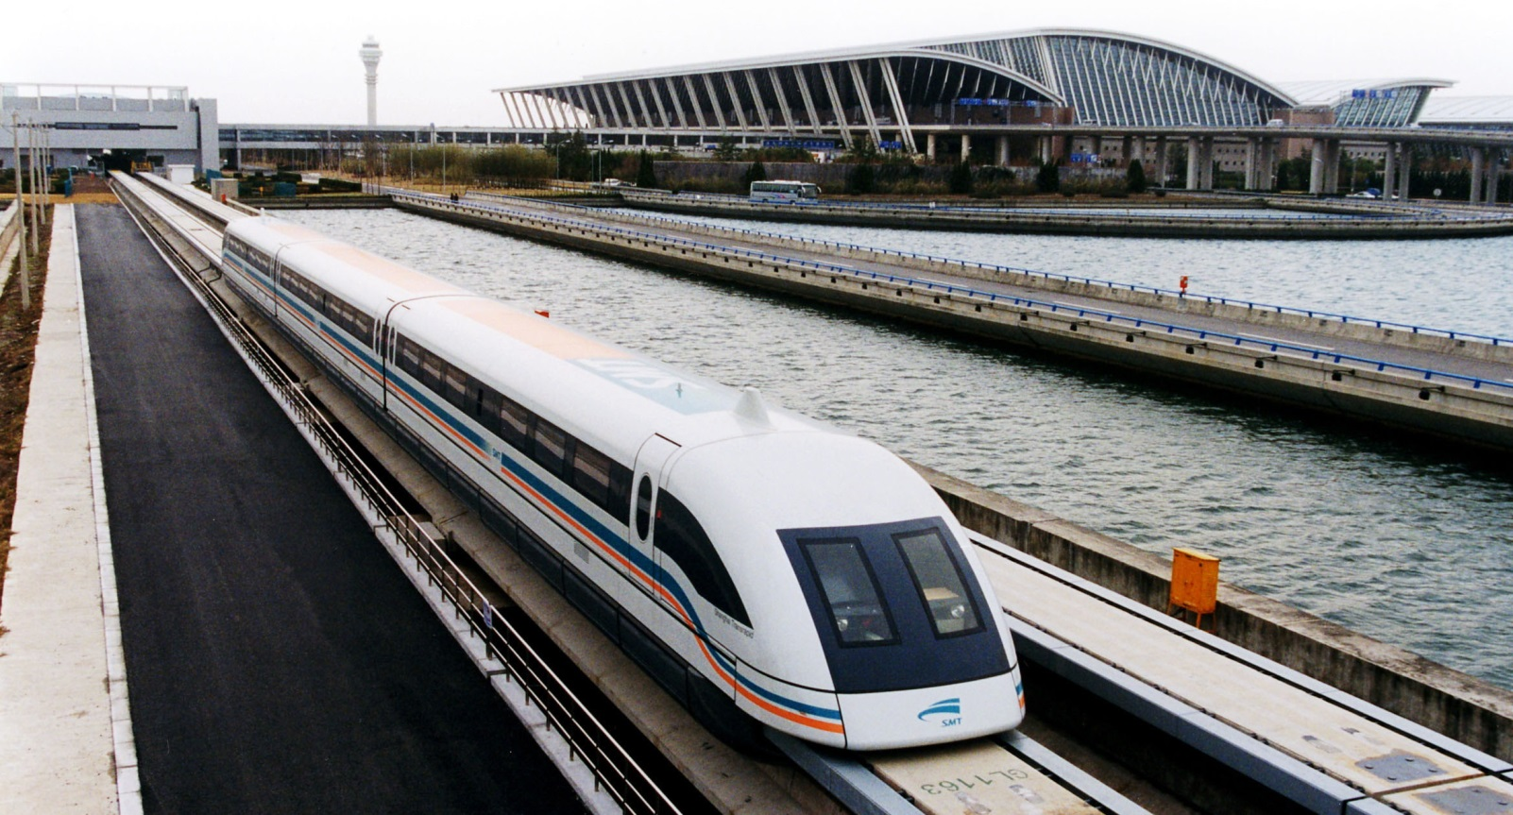

Maglev Train from Shanghai airport

(268 miles an hour)

Military public good for China, getting aircraft carriers

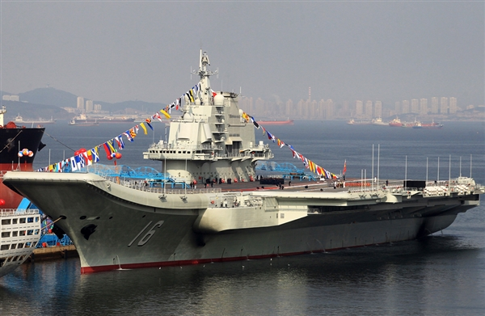

Common Resources

* Nonexcludable
* Rivalrous

Example world fishing stocks

* Can be difficult to exclude people from fishing the oceans.
* Certainly rivalrous as overfishing has depleted important fish stocks.

“Tragedy of the Commons”

Another example: people using iPad to watch movies in hotels