Lecture 8(ii)

Office Hours Today:

1:30-3:25

4-135 Hanson

Lecture

0. Finish up public goods in Econland

Consumer Theory

1. Budget Constraint

2. Preferences: Perfect Substitutes

3. Preferences: Perfect Complements

4. Preferences: In between

5. Choice

I never told you this, but Econland has no sun! (So dark all the time)

Proposal: Build an artificial sun, will light all of Econland.

Cost of project is $20.

What is willingness to pay?

:

|  |  |  |  |
| --- | --- | --- | --- |
| Name | would pay | Name | would pay |
| D1 | 9 | S1 | 0 |
| D2 | 8 | S2 | 0 |
| D3 | 7 | S3 | 0 |
| D4 | 6 | S4 | 0 |
| D5 | 5 | S5 | 0 |
| D6 | 4 | S6 | 0 |
| D7 | 3 | S7 | 0 |
| D8 | 2 | S8 | 0 |
| D9 | 1 | S9 | 0 |
| D10 | 0 | S10 | 0 |

If this were a private good at a cost of $20 per unit, the efficient amount would be zero.

Public good: Add the willingness to pay of each together.

If the artificial sun is build, all get to enjoy it.

Social Marginal Benefit from building the artificial sun is:

9 + 8 + 7 + 6 + 5 + 4 + 3 + 2 + 1

= $45.

Greater than $20.

So socially efficient to build the artificial sun.

In the free market, there is a:

**free rider problem**.

Beneficial on net for society as a whole, but no one willing to put up the whole amount to do it themselves.

Have a role for government.

Gov’t were to tax D1-D4 $5 each, there would be a Pareto improvement

One last point: because of technological change things can become excludable that before were not excludable, and the other way.

Suppose can build an artificial sun where you need a certain kind of sunglasses to see the light.

Entrepreneur build the artificial sun, sell sunglasses to people for $5

D1-D5 buy, get $25 in revenue. Pays for the $20 investment.

The good is now excludable.

Key point: in this case will need intellectual property protection to get the innovation.

If someone can sell bootleg sunglasses, then the entrepreneur unlikely to be able to make a go of it.

So won’t get the investment in the first place.

Economic Logic of intellectual property protection like patents and copyrights

Free rider problem getting rich nations subsidize new low-carbon technologies

Connect earlier with discussion of China. China’s economy now huge. Can pay for fantastic Olympics and Expo, even if individuals are poor on average.

Greece, a richer country but smaller, busted its budget on the 2004 Olympics.

China gets a big payoff from investing in nonrivalrous goods (public infrastructure). Can divide costs lots of ways!

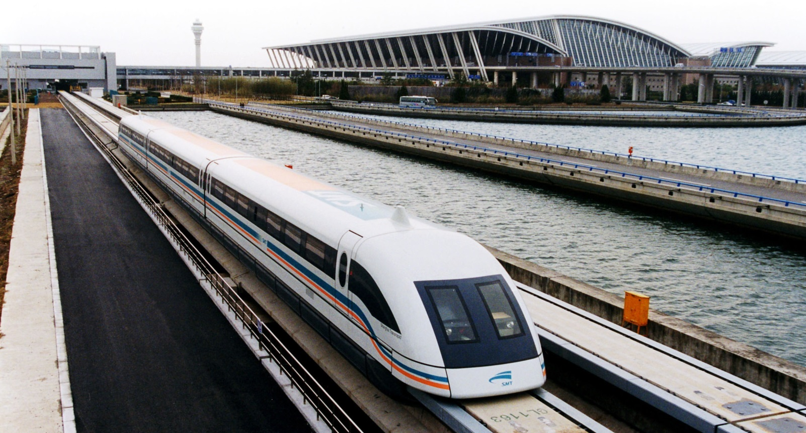

Maglev Train from Shanghai airport

(268 miles an hour)

Military public good for China, getting aircraft carriers

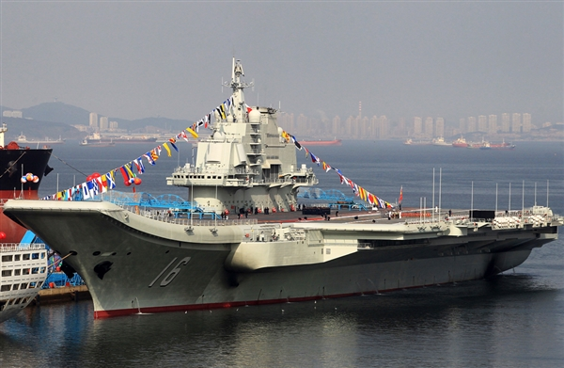

Common Resources

* Nonexcludable
* Rivalrous

Example world fishing stocks

* Can be difficult to exclude people from fishing the oceans.
* Certainly rivalrous as overfishing has depleted important fish stocks.

“Tragedy of the Commons”

Another example: people using iPad to watch movies in hotels

Consumer Theory

* Out with widgets!
* Out with fish and coconuts!
* In with beer and pizza!

* Similar to fish and coconuts, use new graph with two goods.
* Use the graph to see how demand changes when any of the following change:
  + Price of Beer
  + Price of Pizza
  + Income

Budget Constraint



Suppose:

* Goldy has income: I = $24
* Price of pizza: Ppizza = $4 slice
* Price of beer: Pbeer = $2 bottle

Make a table of what Goldy can afford.

|  |  |
| --- | --- |
| Pizza | Beer |
| 0 | 12 |
| 1 | 10 |
| 2 | 8 |
| 3 | 6 |
| 4 | 4 |
| 5 | 2 |
| 6 | 0 |

Plot Budget Constraint



* Horizontal intercept = I/Ppizza
* Vertical intercept = I/Pbeer
* Slope = Ppizza/Pbeer = 4/2 = 2Key thing to know:

Slope of budget constraint is

Opportunity Cost 1 more pizza

(in terms of beer)

1 more slice of pizza costs:

2 bottles of beer.

What happens when price of pizza falls to Ppizza = $2.

New budget constraint.

Opportunity cost of one pizza slice?

Budget constraint tells us what the consumer can do.

What does the consumer want to do?

Depends on the preferences of the consumer.

Consumer will get different utility from different combinations of pizza and beer.

Will make the choice that maximizes utility. We will call this choice the optimal consumption bundle.



Going to go around

.

Assume the mascots consume only pizza and beer.

All the mascots have the same income and face the same prices.

But differ in preferences.

We will explain their preferences and then look at their choices.

Case 1: Hawkeye

(Perfect Substitutes)

Hawkeye gets utility from calories (the more the better).

Suppose pizza 200 calories and beer is 200 calories

Utility = 200*Qpizza + 200*Qbeer

What bundle maximizes utility?

Remember Pbeer = 2, Ppizza = 4.Calculate utility per dollar spent on each good:

Pizza:

Beer:

Beer is the best value (at these prices) in terms of utility per dollar spent.

Hawkeye will spend all his money on beer. Qbeer =

Qpizza =

What is point of the picture?

Gives us another way to figure out the optimal consumption bundle.

Introduce concept of:

Indifference curves:

Combinations of beer and pizza that give the same utility (the consumer is indifferent.

Indifference curve through

Qbeer = 12 and Qpizza = 0

Utility = 200*Qpizza + 200*Qbeer

Get 200 each way, so trade off one-for-one.



What about?

Indifference curve through

Qbeer = 14 and Qpizza = 0

Indifference curve through

Qbeer = 6 and Qpizza = 0

Rule: pick the bundle on the budget constraint that gets to the highest indifference curve

The slope of indifference curve is The Marginal Rate of Substitution

Here one for one. (value of one more pizza slice in terms of beer).

Look again at

Qbeer = 12 and Qpizza = 0 on the budget constraint. At this point:

Value of one more unit of pizza:

one beer

Cost of one more unit of pizza:

two beers

Case 2: Bucky Badger

Fixed Proportions

Very particular:

A meal: one beer and one pizza

Utility equals number of meals.

Suppose Bucky has I = 24 just like before and Ppizza = $4 and Pbeer =$2

What is optimal consumption bundle?

How much for a meal?

How many meals can he buy?

So Qpizza = 4 and Qbeer = 4 in optimal consumption bundle.

Picture?



Case 3: Goldy Gopher

In between these extreme cases

Diminishing marginal rate of substitution.

Meaning, as he eat more pizza, his willingness to give up beer to get even more pizza goes down.

Means indifference curves have a bowed shaped.



Suppose

PBeer = $2, PPizza = $4, I = $24

At optimum two conditions:

(1) On budget constraint and

(2)

Ppizza

MRS = _______

Pbeer

Marginal benefit of pizza (in beer)

=

Marginal cost of pizza (in beer)