Lecture 9(ii)

Announcements

* Work on “Consumer Theory” worksheet for recitation

* Vote on 3 policy platforms at week 10 at Canvas. (need to do this to get bonus points for HW 8
* Office hours today: 1:30-3:25

(4-135 Hanson)

Lecture

1. Review Cost table from last class, to work out case of:

U-Shaped average cost

2. Constant returns to scale

3. Economies of Scale

4. Examples of Wal-Mart and Amazon

5. Short-run Supply of Competitive Firm

Cost Table of S11

|  |  |  |  |  |  |  |  |
| --- | --- | --- | --- | --- | --- | --- | --- |
| Q | FC | VC | TC | MC | A  F  C | A  V  C | A  T  C |
| 0 | 4 | 0 | 4 | 8  6  4  2 |  |  |  |
| 1 | 4 | 2 | 6 |  | 4 | 2 | 6 |
| 2 | 4 | 6 | 10 |  | 2 | 3 | 5 |
| 3 | 4 | 12 | 16 |  | 1.33 | 4 | 5.33 |
| 4 | 4 | 20 | 24 |  | 1 | 5 | 6 |

C for “cost,” F for “fixed,”

V for “variable,” T for “total,”

A for “average,” M for “marginal.”

S11’s Cost Structure

Example of U-Shaped Cost Curve



Points of interest.

1. For Q<2, ATC falling

Region of:

Increasing returns to Scale

(also called economies of scale)

2. For Q>2, ATC rising

Region of:

Decreasing returns to scale

(also called diseconomies of scale.)

3. Q = 2, Minimum Average Cost

Facts:

Q<2, MC<ATC and ATC falling

Q>2, MC>ATC and ATC rising

Q = 2, MC=ATC and at ATC min.

Constant Returns to Scale

As increase production, scale up all inputs in the same proportion. So costs increase proportionately.

Example: Housepainting

S12’s Cost Structure

|  |  |  |
| --- | --- | --- |
| Q | TC | ATC |
| 0 | 0 | - |
| 1 | 5 | 5 |
| 2 | 10 | 5 |
| 3 | 15 | 5 |
| 4 | 20 | 5 |

TC = 5Q

Graph of S12’s Cost Structure



Economies of Scale

(Over entire range of Q)

S13 has FC = 8 and

constant marginal cost of 2

TC = 2Q + 8

ATC = TC/Q = 2 + 8/Q

|  |  |  |
| --- | --- | --- |
| Q | TC | ATC |
| 0 | 8 | - |
| 1 | 10 | 10 |
| 2 | 12 | 6 |
| 3 | 14 | 4.7 |
| 4 | 16 | 4 |
|  |  |  |
| 8 | 24 | 3 |

Graph of S13’s Cost Structure



Here ATC is always falling, never turns back up. So decreasing over entire range of Q

Example industries where scale economies are important

Pharmaceuticals

Fixed cost for research

Marginal cost of making pills small compared to AFC

Software: MC quite low relative to AFC. MC when distribute on internet = 0!

Jumbojet passenger planes with more than 500 people.

(Airbus 380), $16 billion in development costs before fly first plane.

Discount Retailing: By maintaining large scale, Wal-Mart has keep average total costs from its logistics low

For example, there are fixed cost to set up a distribution center. By putting many stores close to distribution centers, Wal-Mart enjoys economies of scale (and can keep inventories low and replenish empty shelves quickly. e.g. restocked flags on 9/11)

Can read about strategy of packing stores close to each other to enjoy economies of density in [my paper](my%20paper). <http://www.econ.umn.edu/~holmes/papers/ecta7699.pd>

f

The paper is technical, so let’s just look at the a movie of how Wal-Mart rolled out its store openings

<http://www.econ.umn.edu/~holmes/papers/Wal-Mart_Stores_and_RegDCs.wmv>

In industries were scale economies are huge relative to the market size, there is only room for a few players.

Discount Retailing: Wal-Mart, Target, K-Mart, plus regional players.

Scale Economics in Wal-Mart’s Import Distribution System

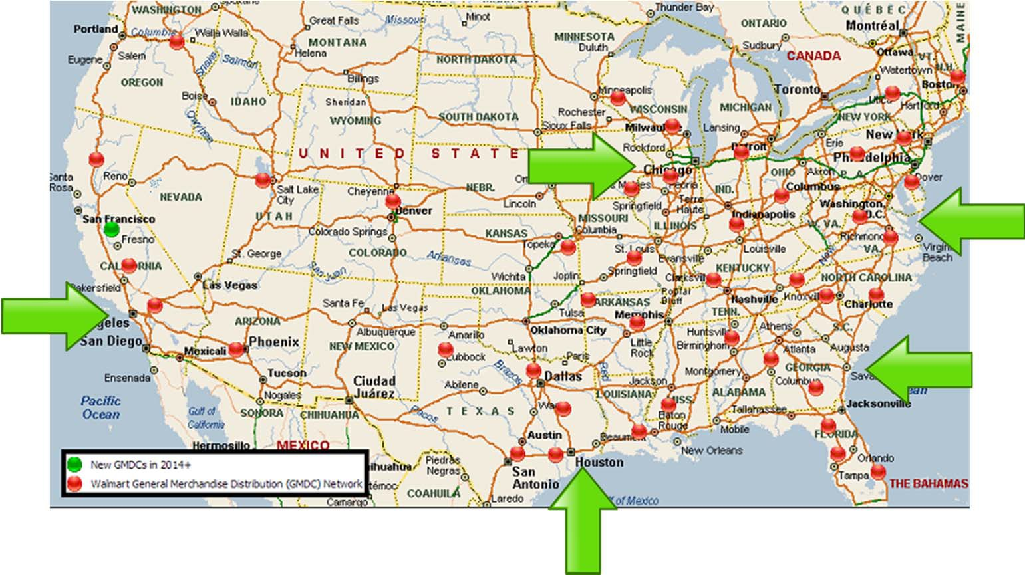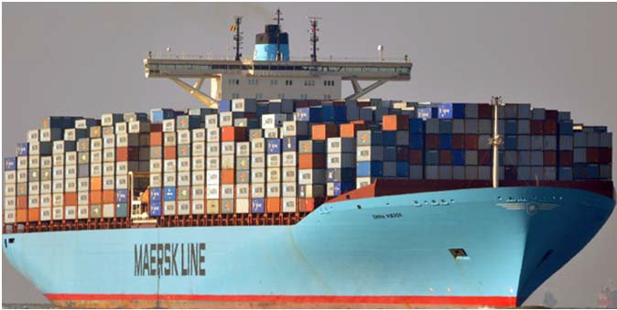

* **China is source of 86 percent of Walmart’s ocean container imports**

(See Holmes and Singer (2017) at my web site).

Big story now: Online Shopping

Early thinking on this: would diminish scale economies because small retailers could tap into UPS and FedEX networks.

Turned out to be the opposite!

To get fast delivery, Amazon is developing its own distribution system.

Amazon’s share of online sales is increasing as the overall market grows.

Fixed cost of “last mile”

Amazon’s model very different from Walmart’s model.

Wide-Body Jets: Boeing, Airbus.

After the midterm, we will talk about industries where individual firms are large. But first, let’s figure out industries where firms are small relative to the market (so firms take price as given.)

Supply of Competitive Firm

Takes P as given

Supply of S1?

Easy. P>1 then Q = 1

P<1 then Q = 0

Supply of S11?

Harder

Suppose P = $7. What does S11 do? One way to figure this out is through a a table

Profit = Revenues minus Total Cost

Pick Q to maximize profit

|  |  |  |  |  |  |
| --- | --- | --- | --- | --- | --- |
| Q | R  P×Q | Total  Cost | Profit  R-TC | MC | MR |
| 0 | 0 | 4 | -4 |  | 7 |
| 1 | 7 | 6 | 1 | 3 | 7 |
| 2 | 14 | 10 | 4 | 5 | 7 |
| 3 | 21 | 16 | 5 | 7 | 7 |
| 4 | 28 | 24 | 4 | 9 | 7 |

Profit maximizing quantity = 3

If MR>MC produce more to raise profit

If MR<MC produce less

If MR=MC? Just right.

Rule for profit maximizing output for a competitive firm:

If produce, set Q where

Marginal Revenue = Marginal Cost

But check whether worth being open at all. When do this make a distinction between short run and long run.Short Run: fixed cost can’t be avoided. Have to pay the rent.

(For S11, FC = 4)

S11 can avoid hiring labor, and also buying materials.

When pick output, forget (in short run) about the rent.

Produce as long as P ≥ AVC

Long Run Can exit the industry (not renew lease.) Produce as long as

P ≥ ATC

Short Run Supply

of Competitive Firm

Rule:

* Find quantity such that P = MC

* Check that P ≥ AVC at that quantity, and then produce there.
* Otherwise shut down.

Short Run Supply Curve for S11

